Uplift Resistance of Anchor Plate Using Extended Mohr-Coulomb Model

Kyeong Sun Kim

Table of Contents

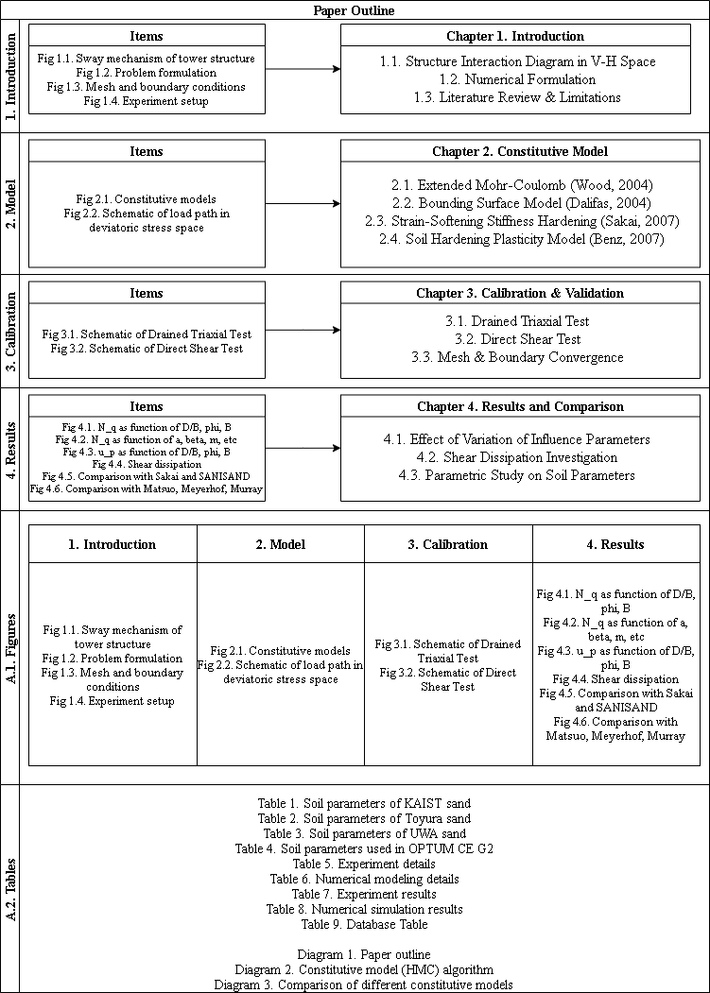

Figure 0.1: Paper Outline

# 1 Constitutive Model

Here is a brief description of the constitutive models:  
1. Strain—Softening Stiffness—Hardening Model by Sakai and Tanaka, 1993  
2. Typical Mohr-Coulomb with Non-associated Flow  
3. Extended Mohr-Coulomb Model by David Muir Wood, 2004

## 1.1 Strain—Softening Stiffness—Hardening Model

It is assumed that the yield function $F$ is defined by the stress $\vec{σ}$ and the soil parameter $χ$ (Tanaka and Sakai, 1993): $F(\vec{σ},α(χ))=0$

In order to avoid numerical instability due to singularity of the non-associated Mohr-Coulomb model, a constitutive model based on the yield function of M-C type and the plastic potential function of Draker-Prager type is employed.

For predicting deformations in a post-peak regime, the elastic- strain-softening plastic model is developed. The yield function is given by the following expression.

### 1.1.1 Yield function

$$F(\vec{σ},α(χ))=3α(χ)p′+\frac{\sqrt{J_{2}}}{g(θ)}−c(χ)=0$$

### 1.1.2 Plastic potential function

$$G(\vec{σ},α′(χ))=3α^{′}(χ)p′+\sqrt{J_{2}}−c(χ)=0$$

$$χ=∫δε^{p}$$

$$(δε^{p})^{2}=2[(δϵ_{x}^{p})^{2}+(δϵ_{y}^{p})^{2}+(δϵ_{z}^{p})^{2}+]+(δγ^{p})^{2}$$

, where $p^{′}$ 
 is mean stress, $J_{2}$ 
 is second invariant of deviatoric stress, $χ$ 
 is soil hardening parameter, $c(χ)$ 
 is apparent cohesion function, $δε_{x,y,z}^{p},δγ^{p}$ 
 is incremental deviatoric plastic strains.

In case of the Mohr-Coulomb model, $g(θ)$ is given by:

$$g(θ)=\frac{3−sinϕ}{2\sqrt{3}cosθ−2sinθsinϕ}$$

, where $θ$ 
 is Lode angle; if triaxial compression, $=−{30}^{∘}$ $ϕ$ 
 is mobilized internal friction angle.

### 1.1.3 Hardening function

The simple strain-softening functions are specified and expressed as a function of material constants. (Tanaka and Sakai, 1993)

$$
\alpha(\chi) = {(\frac{2\sqrt{a\chi }}{\chi +a})}^m \alpha_p\; \\ (hardening \; regime;\; \chi \leq a)
$$

$$
\alpha(\chi) = \alpha_r + (\alpha_p - \alpha_r) exp\{-(\frac{\chi-a}{b})\}\; \\ (softening \; regime;\; \chi > a)
$$

, where $a,b,m$ 
 are soil parameters.

Similar expressions are used by de Borst (1986).

$$α_{p}=\frac{2sinϕ_{p}}{\sqrt{3}(3−sinϕ_{p})}$$

$$α_{r}=\frac{2sinϕ_{r}}{\sqrt{3}(3−sinϕ_{r})}$$

, where $ϕ_{p,r}$ 
 are peak and residual friction angle, respectively.

## 1.2 Nonassociated Flow Rule (NA)

Since there may be a range of possible solutions, each associated with a different pattern of localization and all of which are entirely valid, it can be expected that any numerical solution will be very sensitive to both physical imperfections as well as round-off errors and the exact sequence in which the procedures defining the solution scheme are carried out. In the end, the result is a load-displacement response that tends to be rather oscillatory.

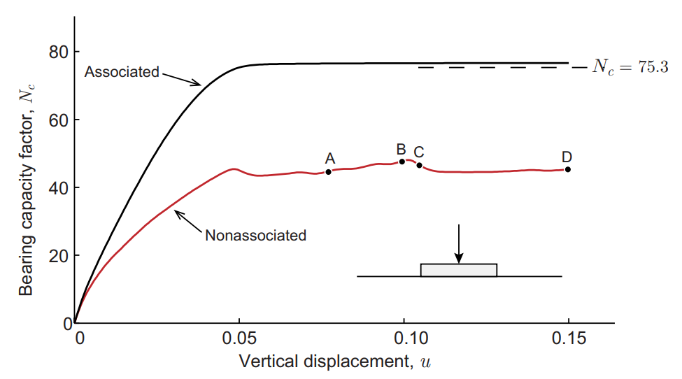

Figure 1.1: Load-displacement response for strip footing on a weightless soil (After Krabbenhoft et al., 2012)

The basic idea behind the formulation derives from the structure of the internal dissipation associated with constitutive models. Let us assume a yield function of the type:

$$F=Mp+q−c$$

, where $p$ 
 and $q$ are mean and deviatoric stress, $M$ is a friction coeffcieint, and $c$ is cohesion.

The plastic potential function is given by:

$$G=Np+q$$

, where $N≤M$ is a dilation coefficient.

In $p−q$ triaxial space, the plastic strain rates are given by:

$$
\delta \varepsilon_v^{p} = \delta \lambda \frac{\partial G}{\partial p} = \delta \lambda N \\
\delta \varepsilon_s^{p} = \delta \lambda \frac{\partial G}{\partial p} = \delta \lambda
$$

, where $δ$ denotes time increment, $ε_{v}^{p}$ and $ε_{s}^{p}$ are volumetic and deviatoric plastic strains conjugate to $p$ and $q$, respectively.

The dissipation $D$ is given by:

$\begin{matrix}D & =pε_{v}^{p}+qε_{s}^{p} \\ & =(Nq+q)δλ \\ & =[c−(M−N)p]δλ \\ & =[c−(M−N)p]ε_{s}^{p}\end{matrix}$

The above-mentioned parameters are all related with the confining pressure, which can be easily illustraed with the figure below:

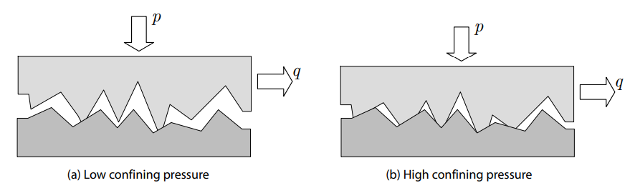

Figure 1.2: Microscopic origins of friction as plastic shearing of asperities. A higher confining pressure implies a higher degree of interlocking of the asperities and thereby a higher apparent shear strength (After Krabbenhoft et al., 2012)

## 1.3 Extended Mohr—Coulomb Model (EMC)

The elastic-perfectly plastic Mohr-Coulomb model is widely used for geotechnical analysis. It provides very crude match to actual shearing behavior of soils. A natural extension is to create a hardening version of the M-C model in which the size of the yield surface varies in some nonlinear way with the development of plastic strain. In the model to be described as hardening will be linked only with distortional strain. It is useful for modelling sands , where it is rearrangement of the rather particles that dominates the response and irrecoverable volumetric changes are essentially linked by this rearrangement of particles (Wood, 2004).

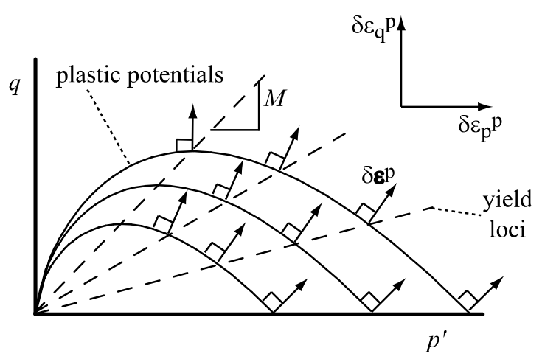

Figure 1.3: Plastic potential curves (solid lines) and yield loci (dashed lines) in elastic-hardening plastic Mohr-Coulomb modele

Following Taylor’s (1948) proposal of a link between dilatancy and mobilized friction in a shear box test, stress—dilatancy equation expressed in terms of total strain increments is obtained.

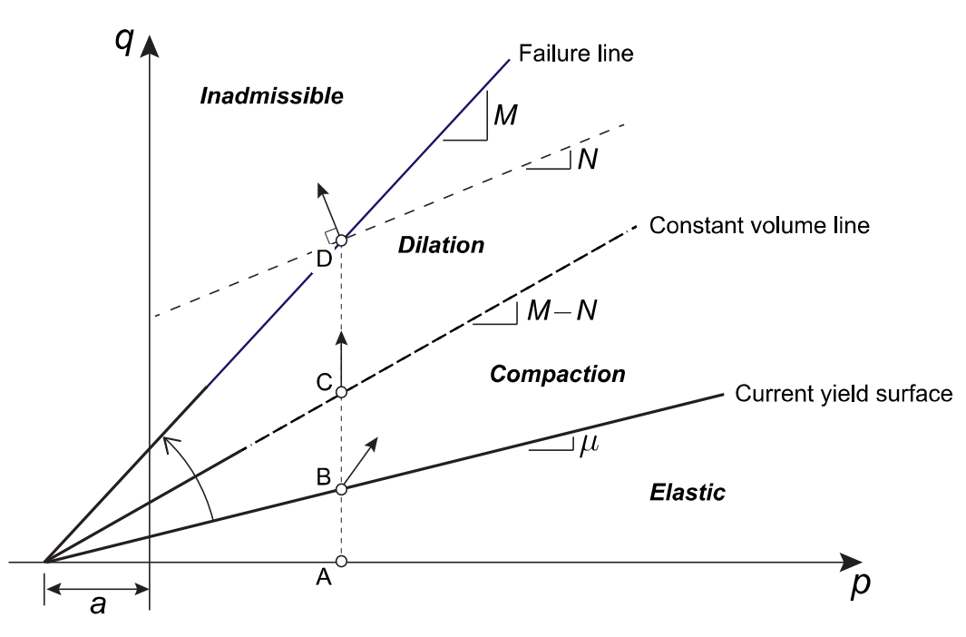

Figure 1.4: Hardening, compaction and dilation in the HMC model

### 1.3.1 Comparison between associated and non-associated flow rule in plastic model

In the elastic-perfectly-plastic Mohr-Coulomb model, it is commonly assumed that the plastic potential takes the same form as the yield surface, but with the slope defined by a dilation angle $ψ$ rather than a friction angle. If this assumption is adopted, then the dirction of the plastic strain increment $δε^{p}$ would be normal to a set of parallel lines by the dilation angle. If normality rule were assumed, radical difference between the slope of yield criterion line and the plastic potental contour is observed (J.P. Doherty and D. Muir Wood, 2013).

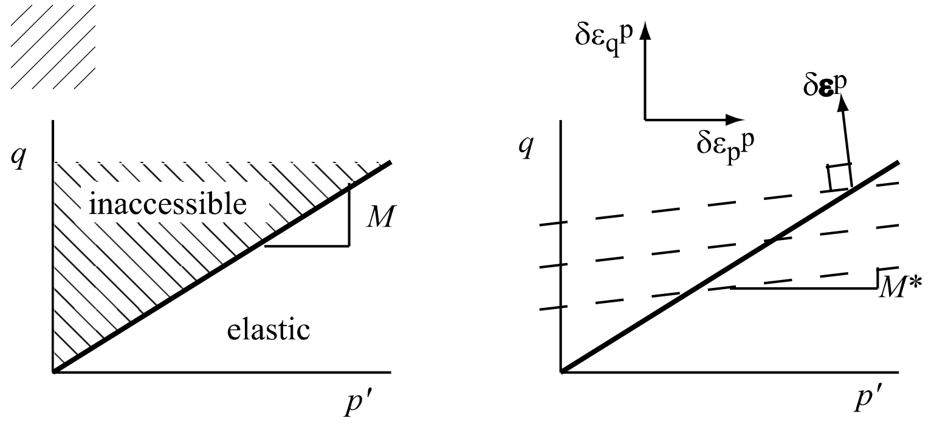

Figure 1.5: Elastic-perfectly plastic Mohr-Coulomb model (a) yield and failure locus, (b) plastic potentials

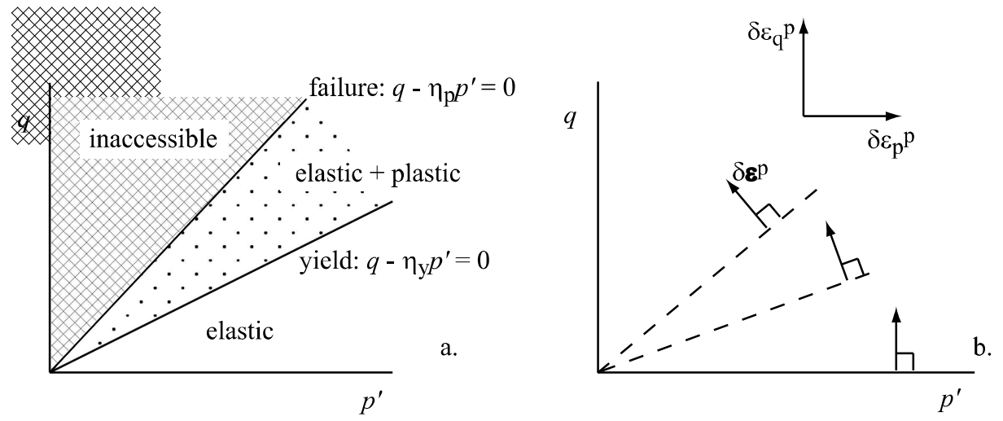

Figure 1.6: Elastic-hardening plastic Mohr-Coulomb model (a) yield locus and failure locus separating elastic plastic and inaccessible regions of stress plane (b) normality applied at the plastic region

### 1.3.2 Yield function

$$F(\vec{σ},χ)=F(p′,q,χ)=q−η_{y}p′=0$$

### 1.3.3 Plastic potential function

$$G(\vec{σ})=q−(M−M′)p′ln(\frac{p_{r}′}{p′})=0$$

, where $η_{y,p}$ is stress ratio at yield and peak, respectively, $p_{r}′$ 
 is chosen s.t. plastic potential gradient passes through current stress, i.e., $p_{r}′=p′exp\{\frac{η_{y}}{M−M′}\}$ $M$
  
 is material parameter at perfect plasticity when hardening terminates. $M=\frac{6sinϕ}{3−sinϕ}$ $M′$
  
 is dilation at constant volume line: $M′=\frac{6sinψ}{3−sinψ}$ $M′=M−kψ=M−k(v−Γ+λlnp′)$ $k$
  
  
 is soil constant linking state variable and strength.  
Critical State description is as follows: $M′=M−k[(v_{0}−Γ+λlnp_{0}′+(λln\frac{p′}{p_{0}′}−v_{0}ε_{p}^{e})−v_{0}ε_{p}^{p})]$ 
.

### 1.3.4 Flow rule

$$\frac{δε_{p}^{p}}{δε_{q}^{p}}=M−M′−η_{y}$$

### 1.3.5 Hardening

$$δη_{y}=\frac{1−\frac{η_{y}}{M}}{β}δε_{q}^{p}$$

, where $β$ 
 is a model parameter scaling plastic strain, $β=\frac{3}{2}p′\frac{9−M}{9−(M−M′)Mln2−3M′}\frac{1−E_{50}/E_{ur}}{E_{50}}$ 
 for Taylor’s $σ−ψ$ relation.

The incremental of the stress ratio is defined as:

$δη_{y}=\frac{3sinδϕ}{\sqrt{3}cosθ+sinθsinδϕ}$

### 1.3.6 Soil Parameters

#### 1.3.6.1 Elastic Moduli

The elastic moduli are estimated from the modified equation proposed by Hardin and Black (1968) in the case of sand:

$$
G = G_0 \frac{(2.17-e)^2}{1+e}\sqrt{p'} \\
K = \frac{1+\nu}{3(1-2 \nu)}G
$$

, where $ν$ 
 is Poisson’s ratio, $e$ 
 is void ratio, $G_{0}$ 
 is initial shear modulus.

#### 1.3.6.2 Peak friction angle

The peak friction angle of $ϕ_{p}$ is estimated from the empirical relations proposed by Bolton (1987):

$$
I_r = D_r[5-ln(\frac{p'}{150})]-1, \; (p' \geq 150 kN/m^2) \\
I_r = 5D_r -1 , \; (p' < 150 kN/m^2) \\
\phi_p = 3I_r + \phi_r
$$

#### 1.3.6.3 Dilatency angle

The dilatency angle of $ψ$ is estimated from modified Rowe’s stress–dilatency relationship:

$$
sin\psi = \frac{sin\phi-sin\phi_r'}{1-sin\phi sin\phi_r'} \\
\phi_r' = \phi_r[1-\beta exp\{-(\frac{\chi}{\epsilon_d})^2\}]
$$

, where $β$ 
 and $ϵ_{d}$ are stress—dilatency material parameters. $E_{50}$ 
 is a secant modulus defined as: $E_{50}=\frac{\frac{1}{2}q_{u}}{ε_{a,50}}$ $E_{ur}$
  
 is unloading/reloading stiffness.

# 2 Calibration and Validation

For the validity of the finite element tests performed, the triaxial elemental test is siumlated with the box of union length. The set up is as follows:

## 2.1 Drained Triaxial Test

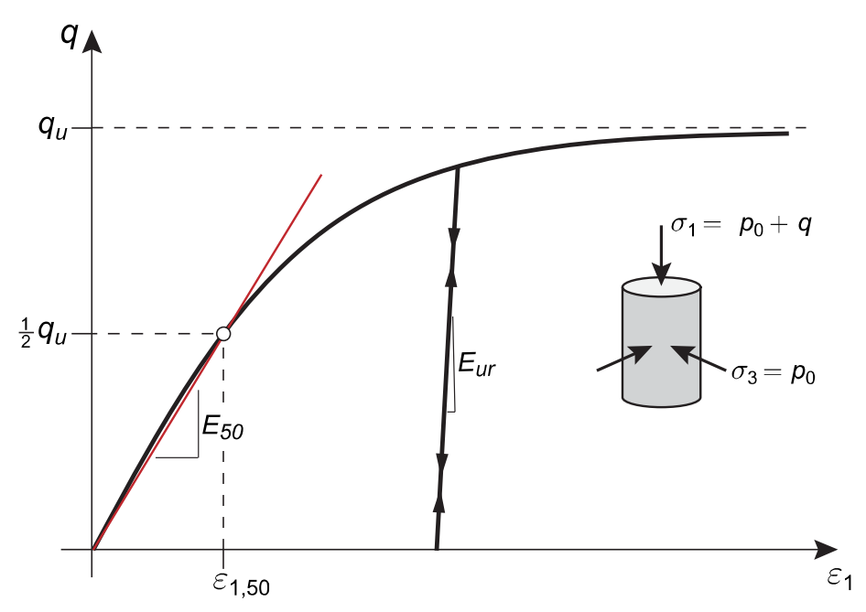

Figure 2.1: Typical triaxial test (After Krabbenhoft, 2013)

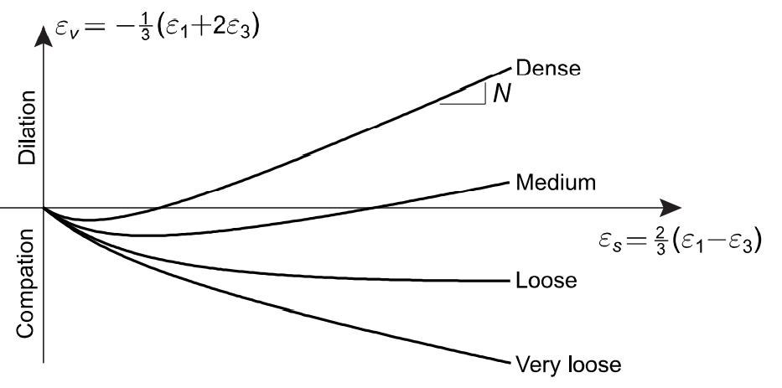

Figure 2.2: Typical shear-volumetric strain behavior in triaxial compression (After Krabbenhoft, 2013)

Two tests — Triaxial compression and extension (TC/TE) — are simulated using Multiplier Elasto—plastic analysis under axisymmetric conditions as indicated in the Figure below. The fixed loads here represent the initial axial and radial stresses while the axial Multiplier load is increased in the course of the analysis to reach the ultimate limit state.

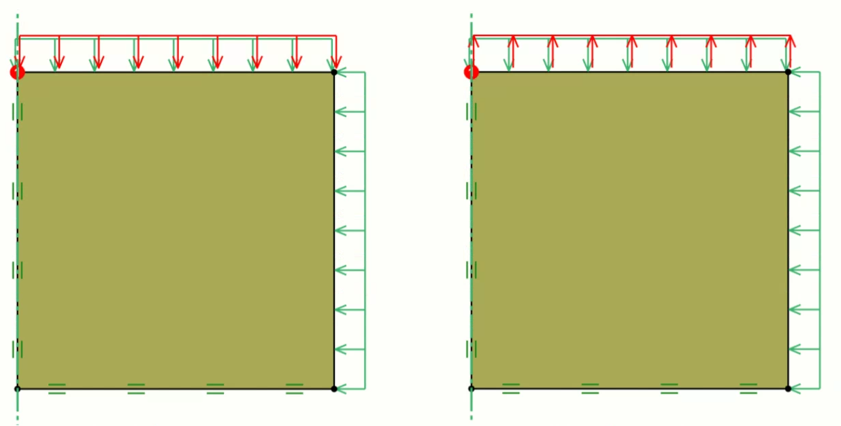

Figure 2.3: Setup for elemental triaxial compression and extension

By a process of trial and error, the fits shown in Figure are obtained. For this data set , where no information about the behavior in simple shear is available the value is well within range that can be accommodated by the isotropic strength option, there is little reason to assume any anisotropy. We note that the compression secant modulus in compression is only half of the extension secant modulus. This is somewhat unusual, but in this case nevertheless what fits the data best.

#### 2.1.0.1 Result of Elemental Triaxial Test at 100 kPa

Triaxial test at radial stress of 100 kPa is simulated using one by one block of the finite elmeent formulation with the EMC model.

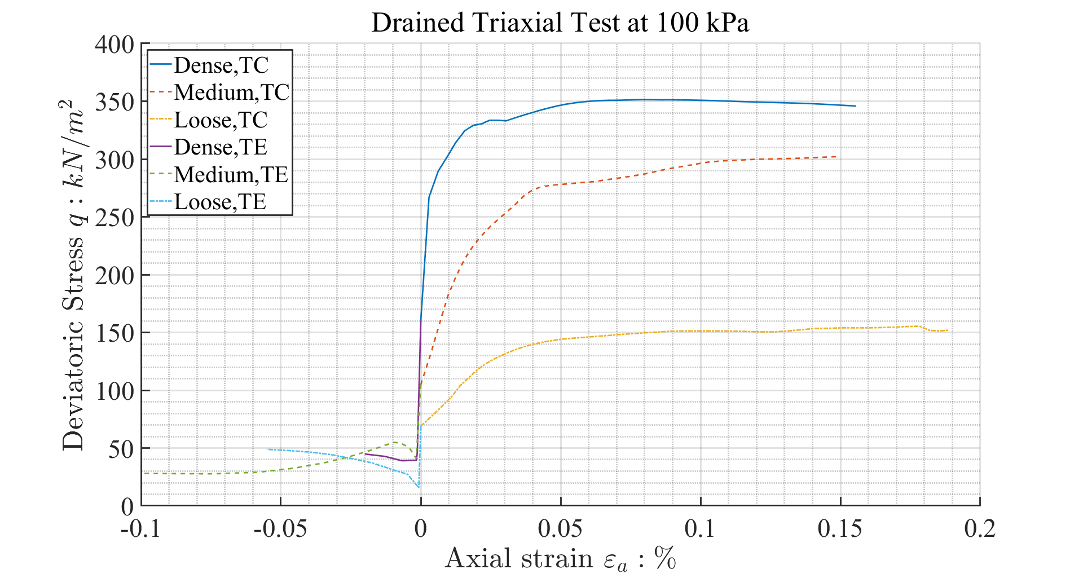

Figure 2.4: Result of Drained Triaxial test at 100 kPa

#### 2.1.0.2 Result of Elemental Triaxial Test at 200 kPa

Triaxial test at radial stress of 200 kPa is simulated using one by one block of the finite elmeent formulation with the EMC model.

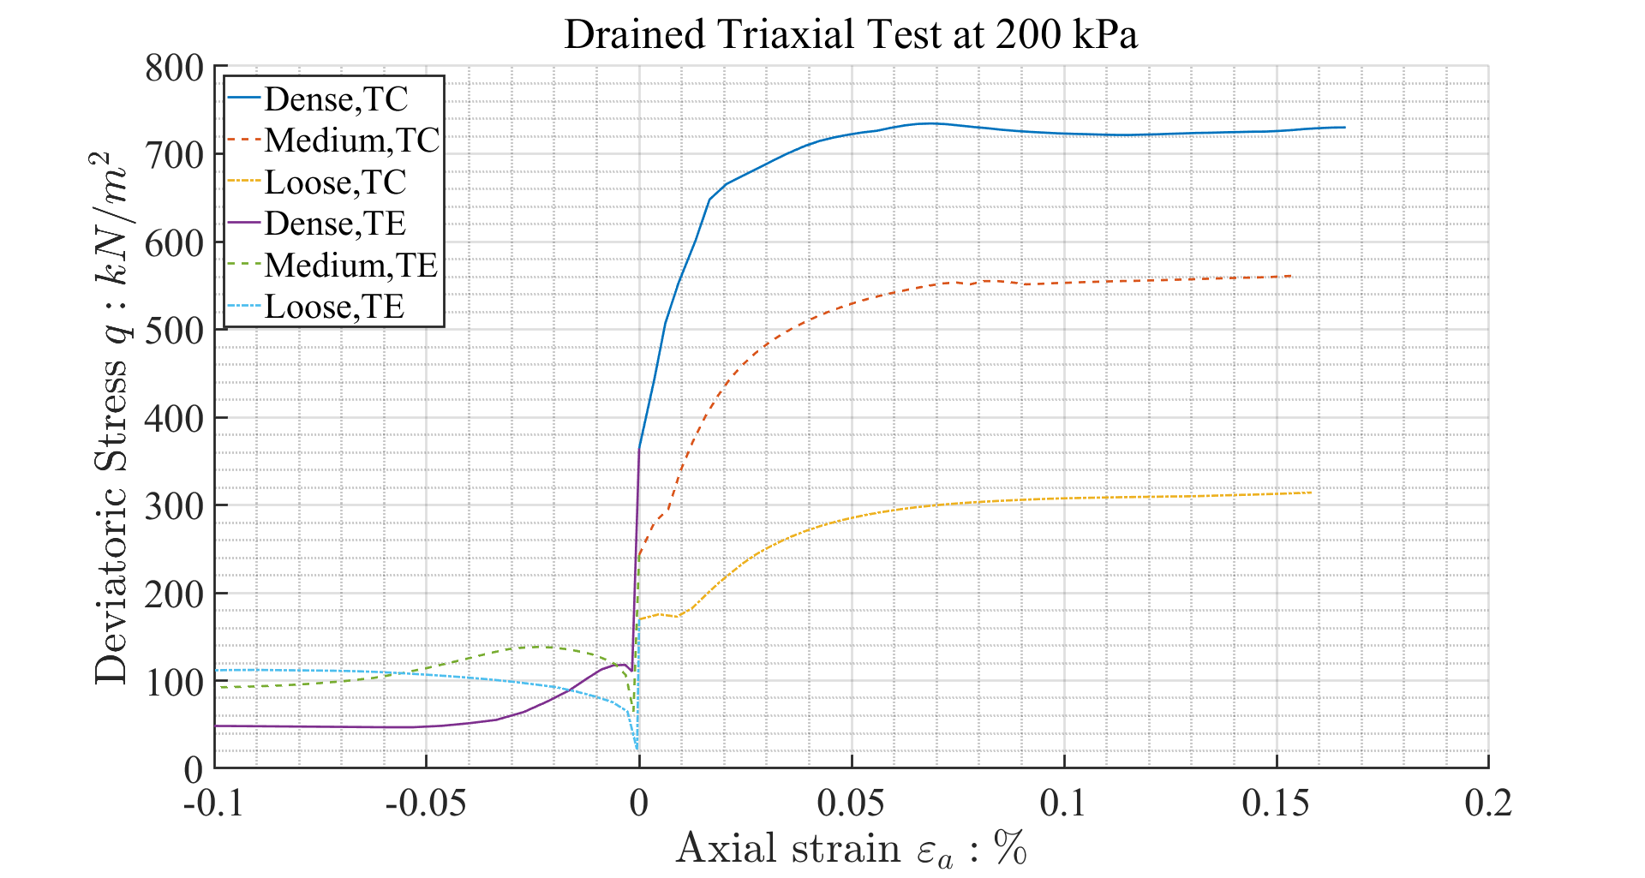

Figure 2.5: Result of Drained Triaxial test at 200 kPa

## 2.2 Soil Parameters

### 2.2.1 Strain—Softening Stiffness—Hardening Model

Here is a table presenting the model parameters used by Sakai and Tanaka (1993).

### 2.2.2 Nonassociated Flow Rule (NA)

Here is a table presenting the model parameters used in Nonassociated (NA) simulations.

### 2.2.3 Extended Mohr—Coulomb Model (EMC)

Here is a table presenting the model parameters used in Extended Mohr-Coulomb (EMC) simulations.

## 2.3 Convergence Criteria

### 2.3.1 Mesh Convergence

Here is a table presenting the result of mesh convergence test on both NA and EMC models.  
The goal of the mesh convergence test usually is to seek the acceptable range of number of the mesh size. However, the interest in the present paper differs from the previously investigated objectives, in a way that the object sought is not the same.  
The present paper seeks to draw a more detailed analysis of the failure surface formed as the soil is sheared.  
Some authors in the past described this with the width of the shear band (Tanaka and Sakai, 1993). However, the present paper deals only with the limit analysis formulation using the Extended Mohr-Coulomb model.

#### 2.3.1.1 Mesh Convergence Results

The reulst of the present investigation is the determination of the number of the mesh elements be around 2000.  
However, it is noted that further studies, outside of this paper, is onto the maximum number of the elements to be studied, for this will enhance the visualization of the shear band formation, as well as the guidance onto the study of the shear dissipation.

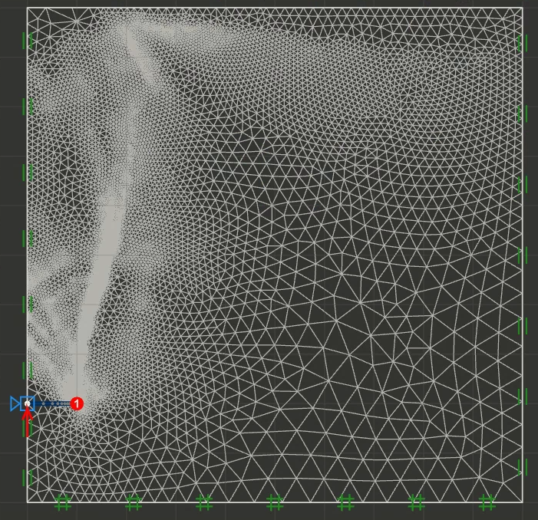

Figure 2.6: Typical result from mesh convergence test (maximum number of elements)

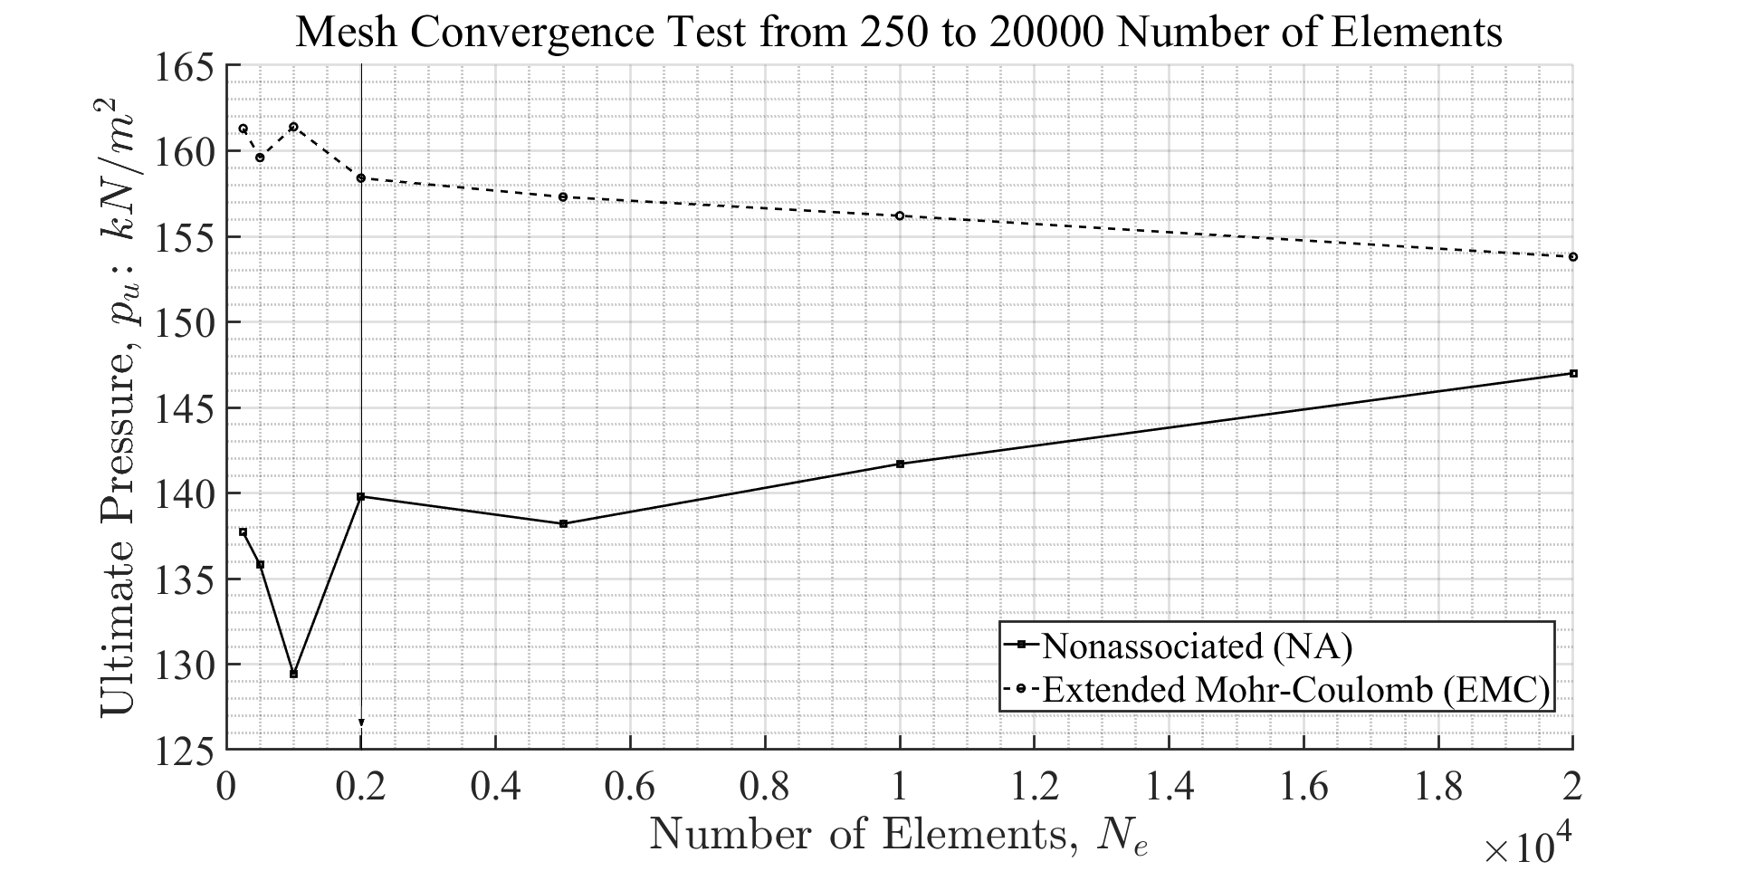

Figure 2.7: Result of the mesh convergence test, which confirms that about 2000 elements are acceptable

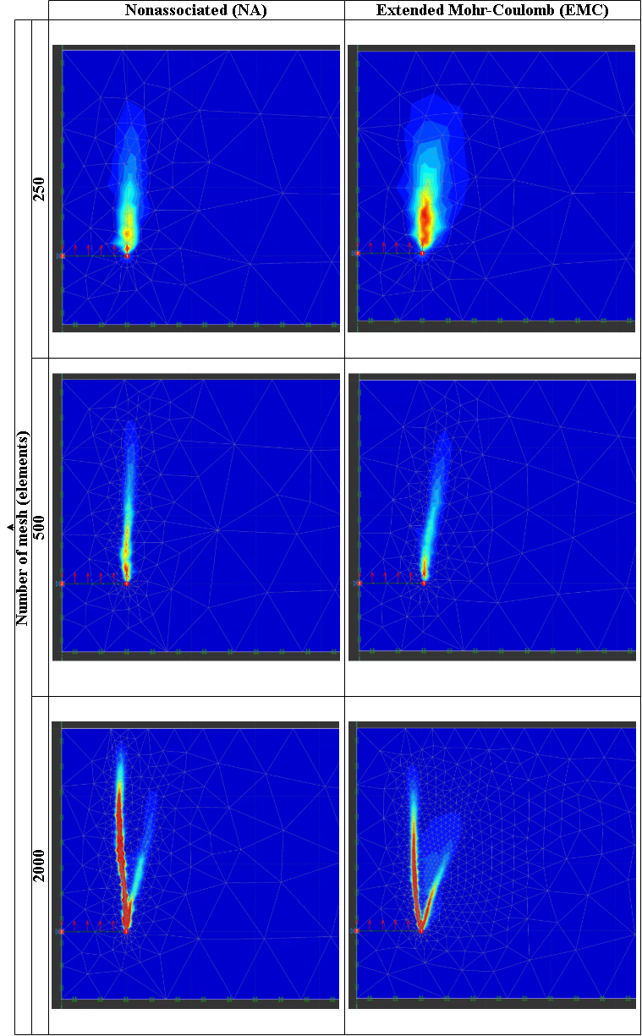

Figure 2.8: Shear Dissipation of the mesh convergence test of 250, 500, 2000 elements

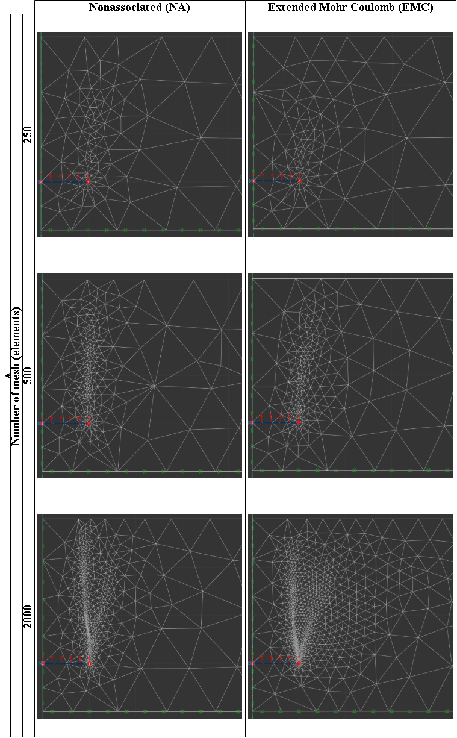

Figure 2.9: Mesh of 250, 500, 2000 elements

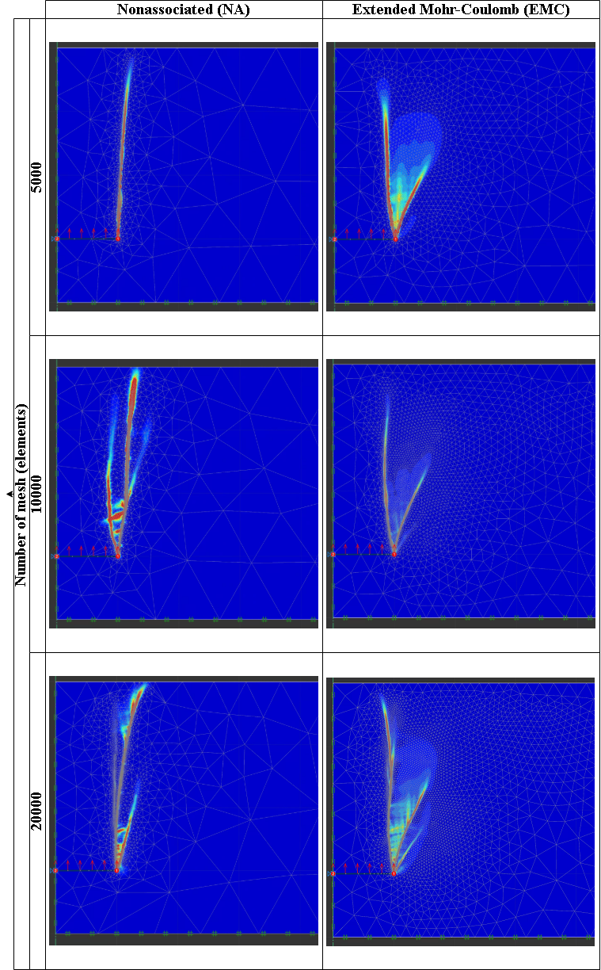

Figure 2.10: Shear Dissipation of the mesh convergence test of 5000, 10000, 20000 elements

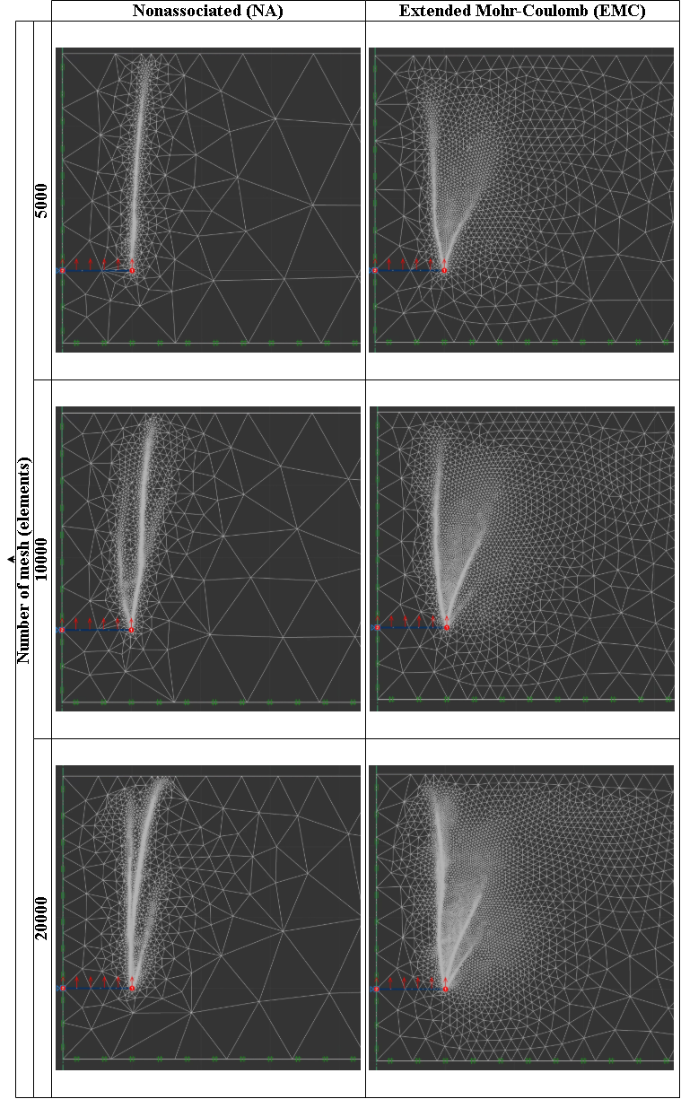

Figure 2.11: Mesh of 5000, 10000, 20000 elements

### 2.3.2 Boundary Convergence

The soil tank width and the distance below the anchor to the soil tank boundary are the primary condern for the modeling.  
Therefore, the optimized value of the soil tank width has been investigated, by differing the values from 10B to 3B, , wherein B refers to the width of the anchor plate.

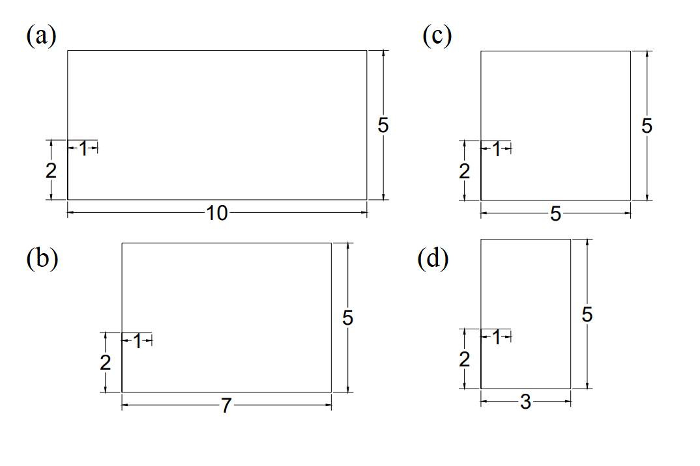

Figure 2.12: Convergence test setup on different boundary size: (a) 10B, (b) 7B, (c) 5B, (d) 3B

Due to the reasoning which considers the method of mesh adaptivity, insignificant effect onto the extension of the soil tank width has been deemed acceptable by the author. Therefore, the result of the boundary convergence test is determined at 10B.

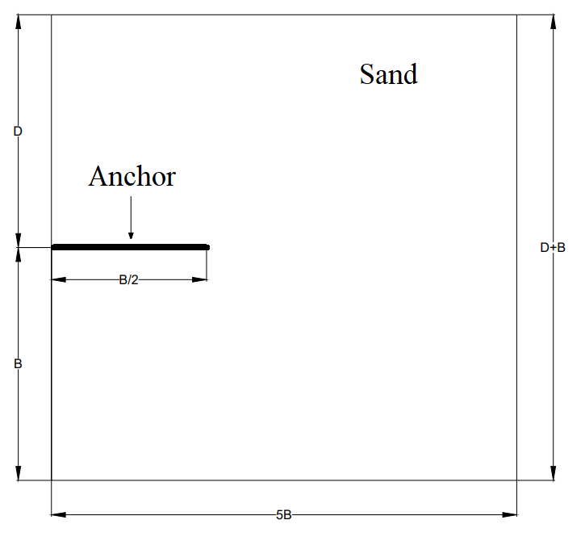

Figure 2.13: Final boundary decision schematic for numerical simulations

Here is a table presenting the setup of boundary convergence test on both NA and EMC models.

#### 2.3.2.1 Boundary Convergence Results

# 3 Results

## 3.1 Parametric Study

Here is a table presenting the setup of the numerical simulations on both NA and EMC models.  
The code refers to the differing width of the plate anchor, , whereas the number specifies if its embedment ratio is either 1, 2, or 3.

### 3.1.1 Effect of Embedment Depth Ratio $\frac{D}{B}$

#### 3.1.1.1 Overall Results with All Range of Dense, Medium, Loose Sands

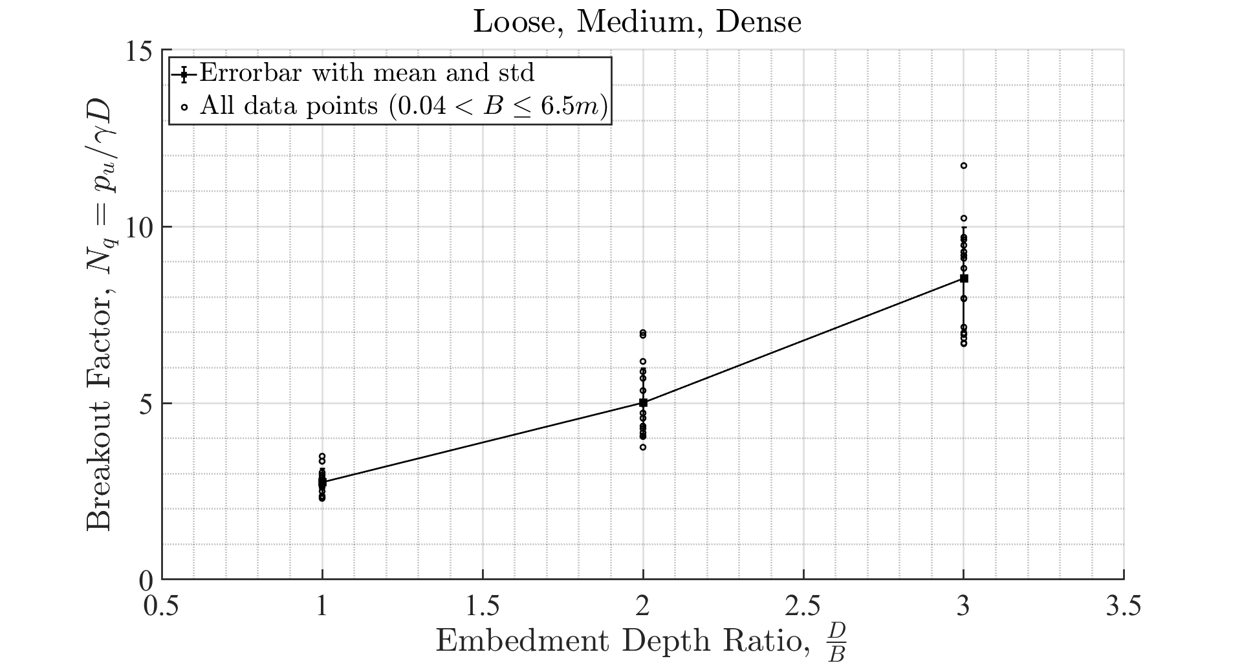

Figure 3.1: Effect of embedment depth ratio on break-out factor for all densities of soil

#### 3.1.1.2 For Different Sand Densities: $Loose,Medium,Dense$

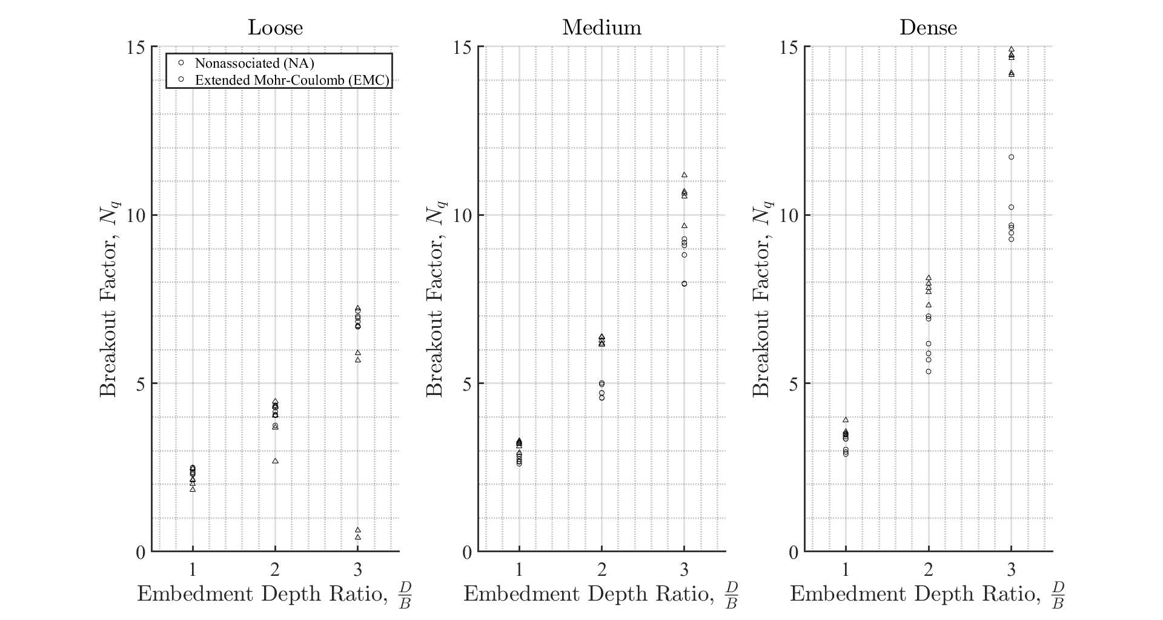

Figure 3.2: Effect of embedment depth ratio on break-out factor (a) loose (b) medium (c) dense

### 3.1.2 Effect of Width $B$

#### 3.1.2.1 Overall Results with All Range of Dense, Medium, Loose Sands

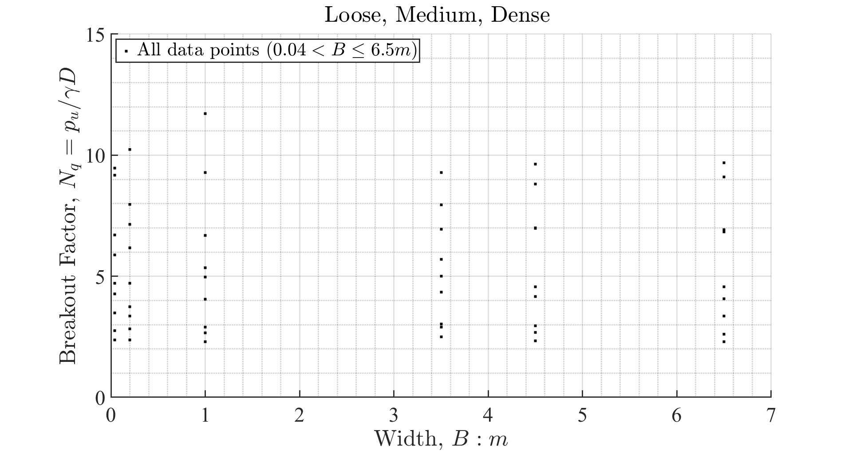

Figure 3.3: Effect of width of plate for all densities of soil

### 3.1.3 Shear Dissipation

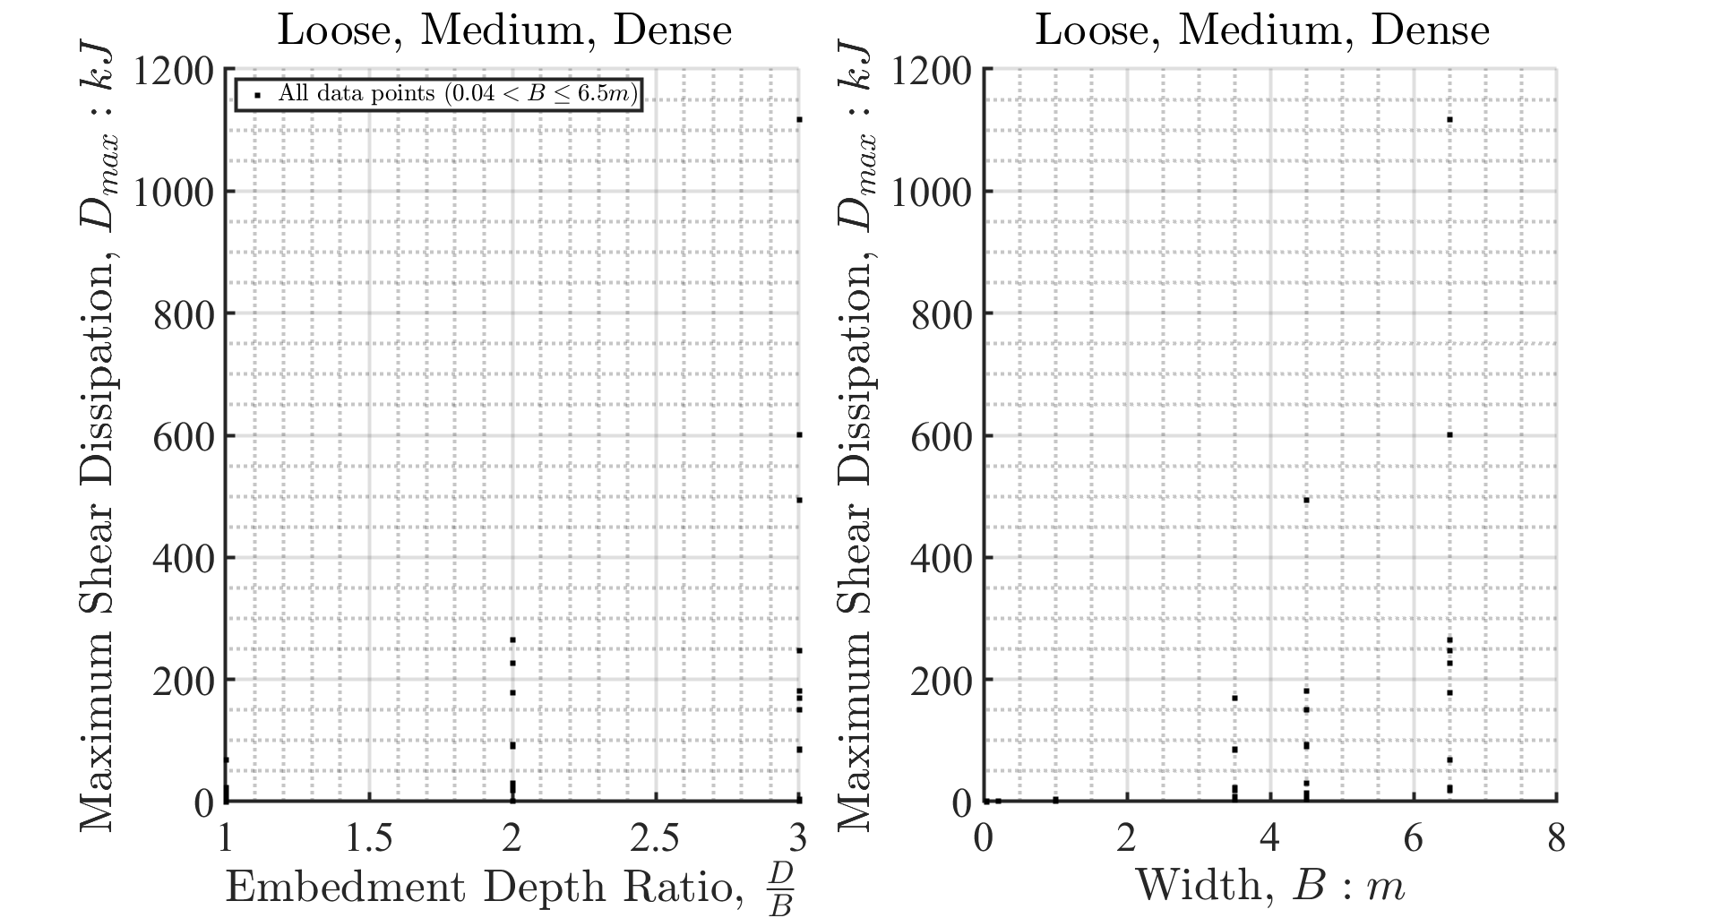

Figure 3.4: Effect of embedment depth and width on shear dissipation for all densities of soil

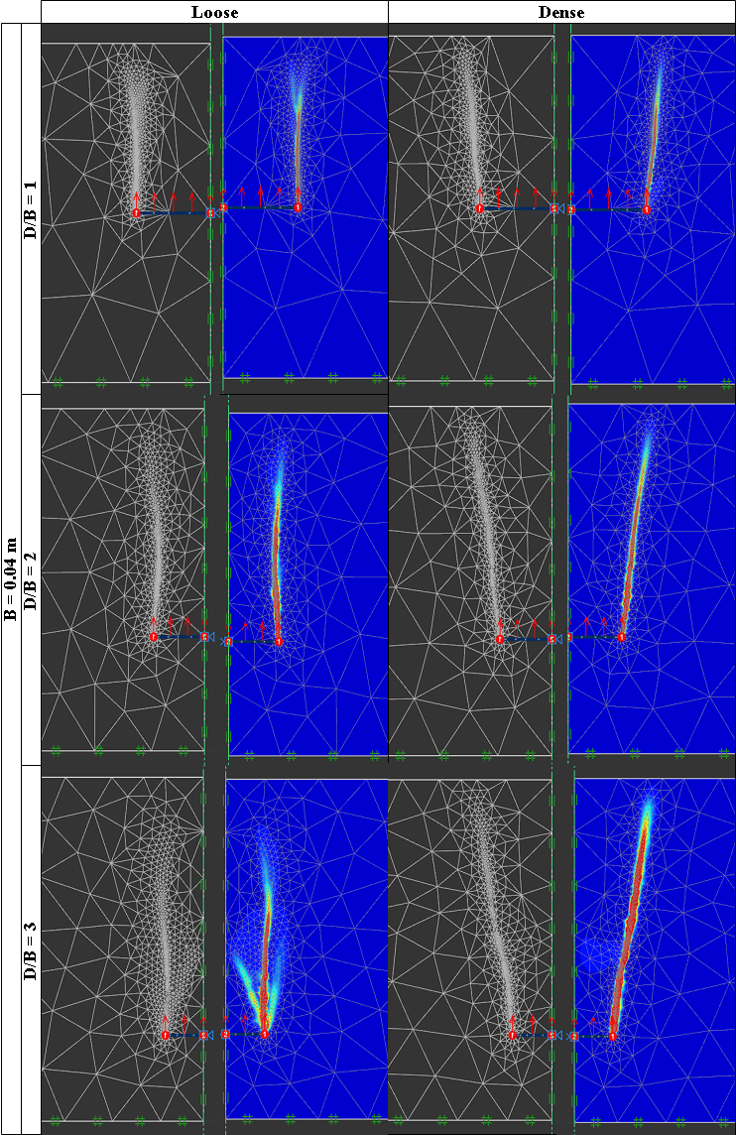

Figure 3.5: Shear dissipation of NA model at 10 percent of the maximum value and $B=0.04m$

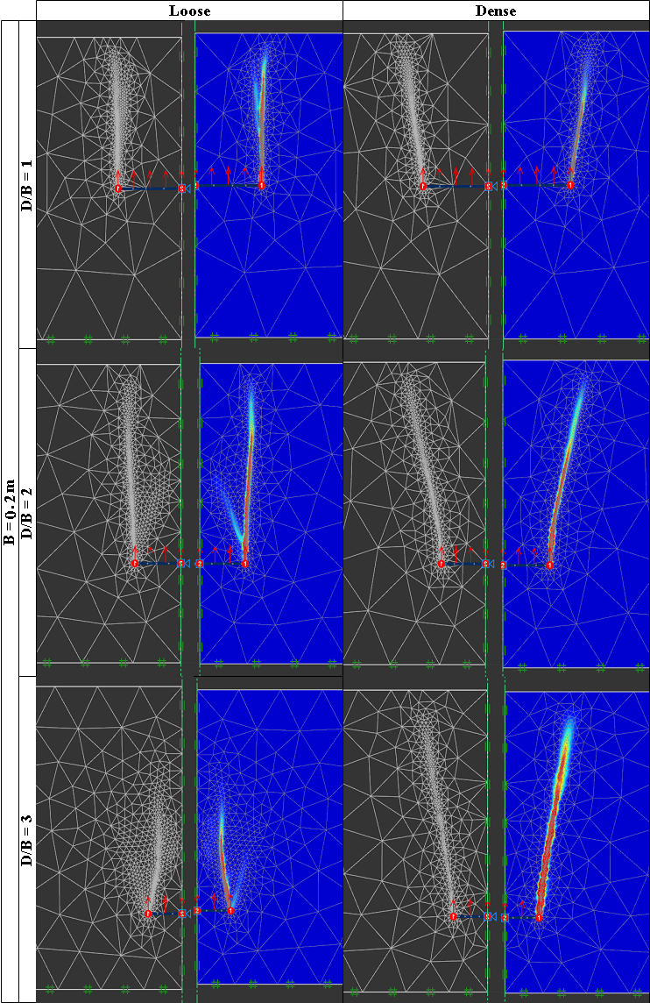

Figure 3.6: Shear dissipation of NA model at 10 percent of the maximum value and $B=0.2m$

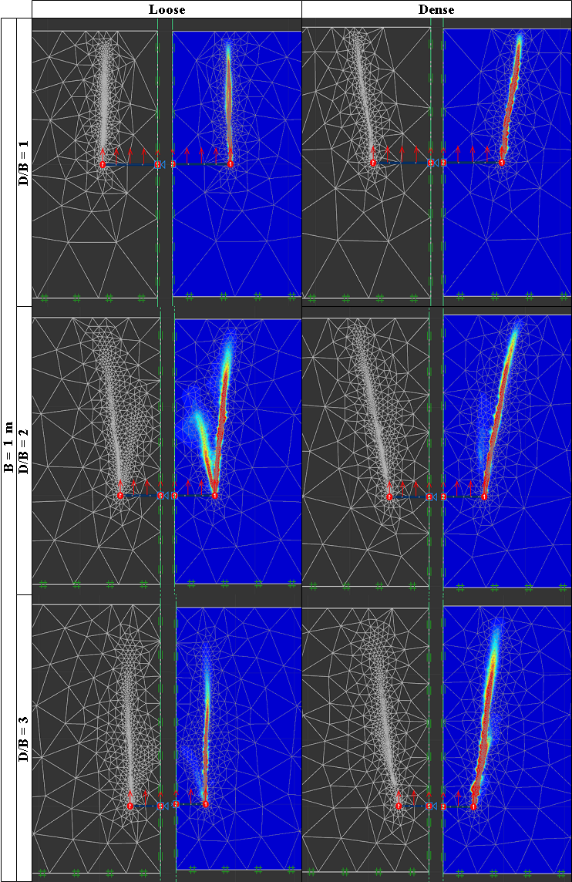

Figure 3.7: Shear dissipation of NA model at 10 percent of the maximum value and $B=1.0m$

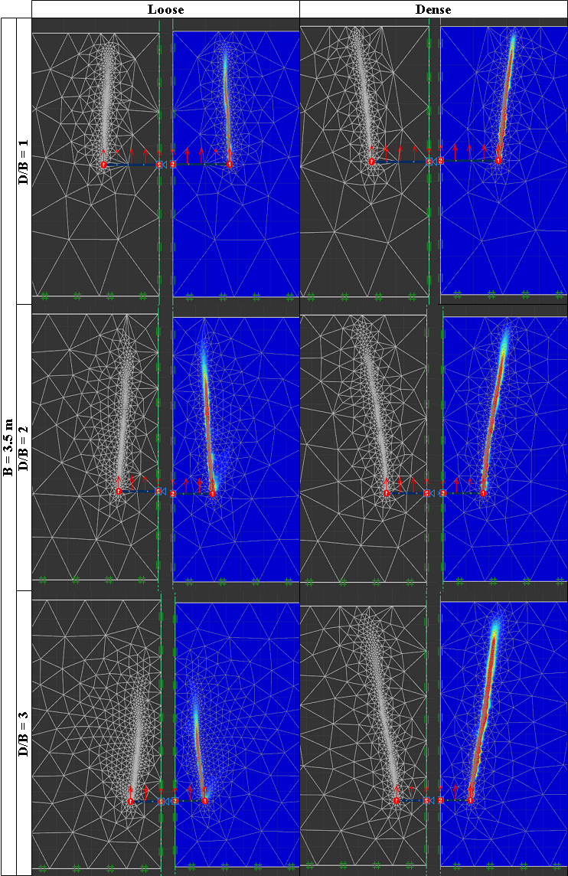

Figure 3.8: Shear dissipation of NA model at 10 percent of the maximum value and $B=3.5m$

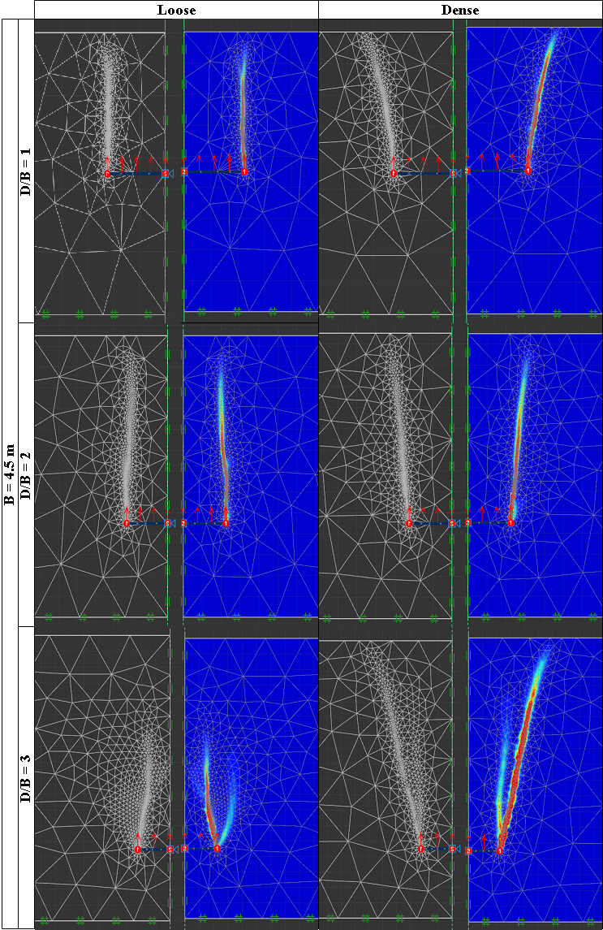

Figure 3.9: Shear dissipation of NA model at 10 percent of the maximum value and $B=4.5m$

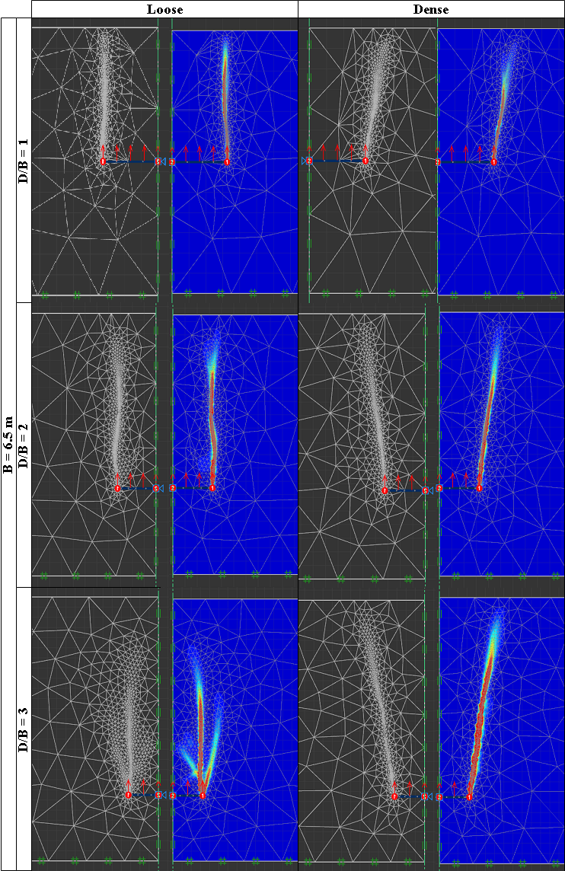

Figure 3.10: Shear dissipation of NA model at 10 percent of the maximum value and $B=6.5m$

## 3.2 Comparison with Previous Researchers

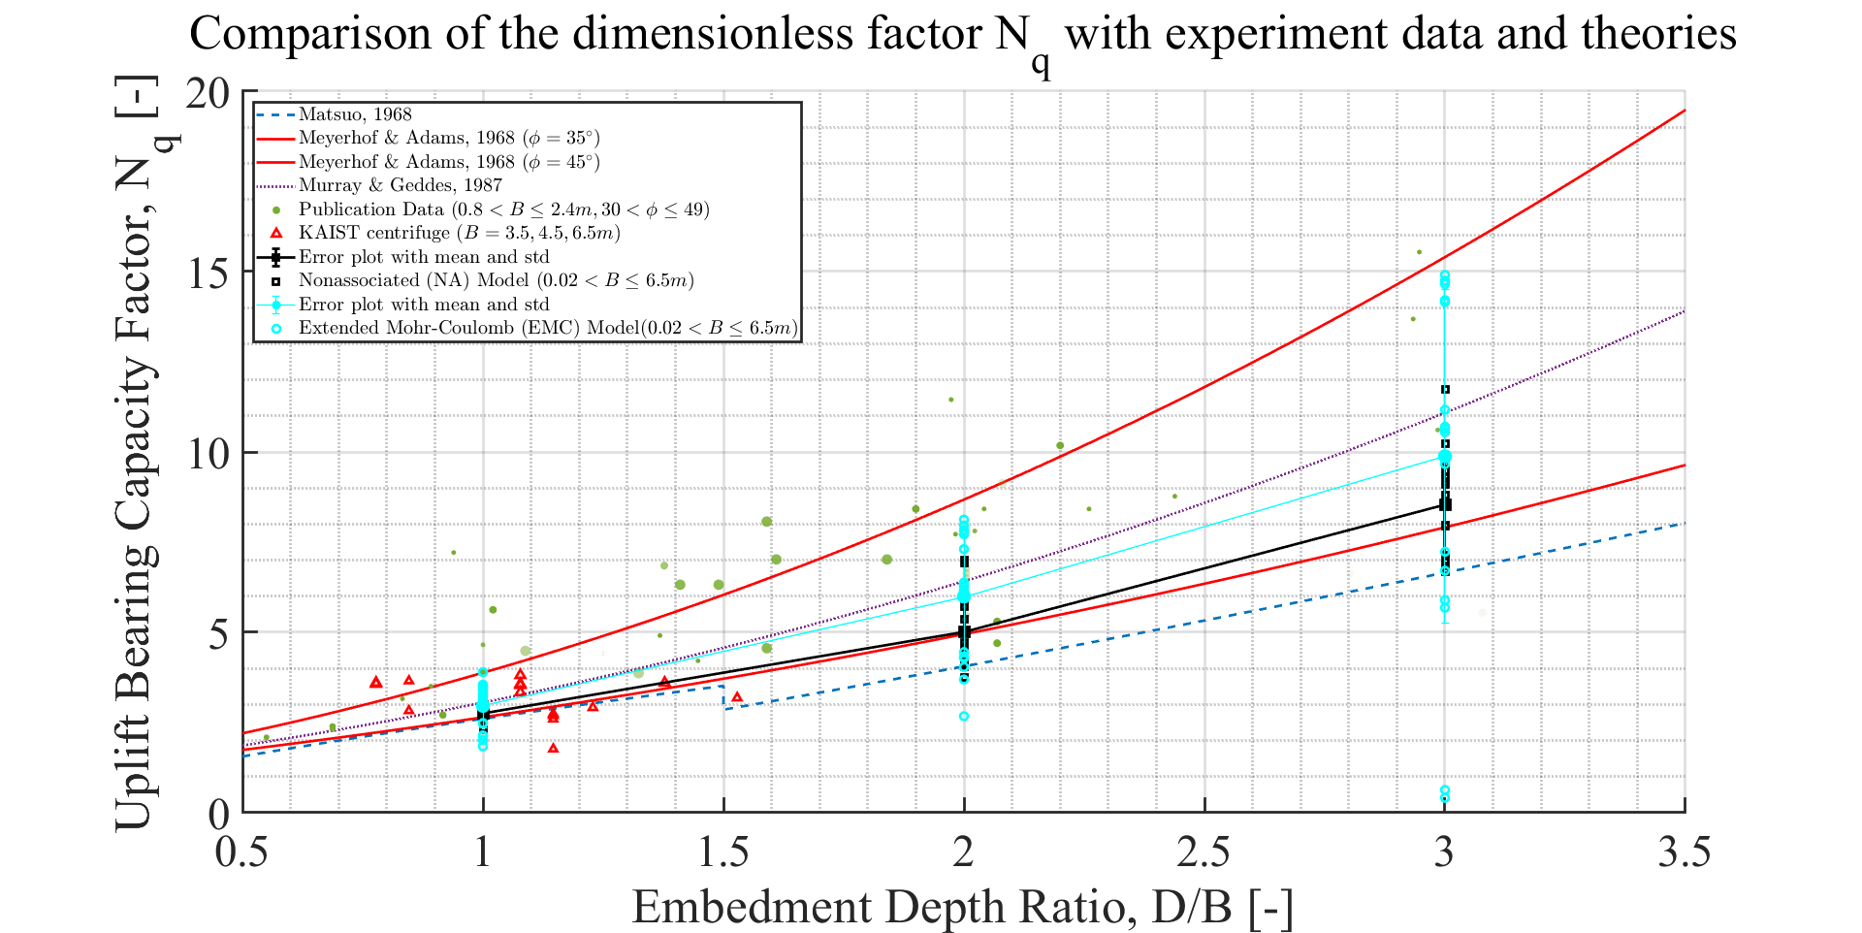

Figure 3.11: Comparison with theories and experimental data in all densities of sands

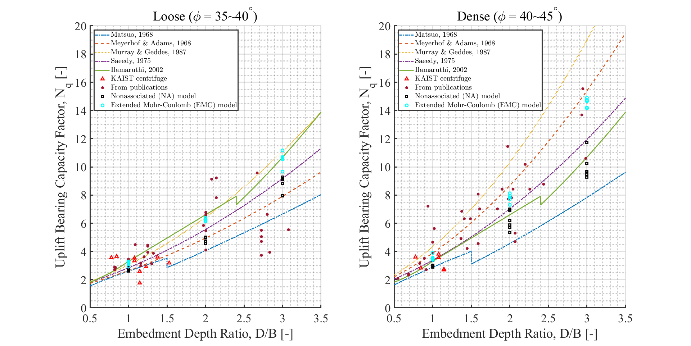

Figure 3.12: Comparison with theories and experimental data in loose and dense sands

#### 3.2.0.1 Comparison of the plot of the effect of width on resistance

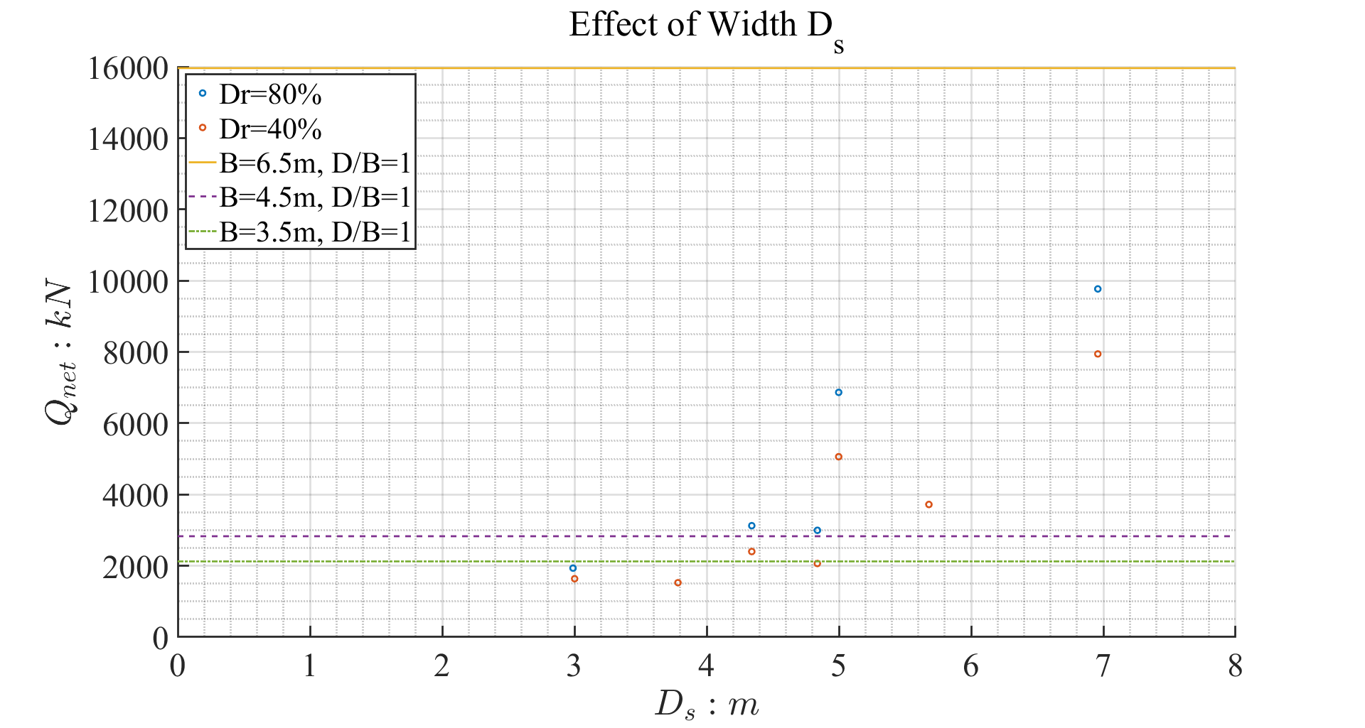

Figure 3.13: Comparison drawn

# 4 Comparison with Centrifuge Experiment

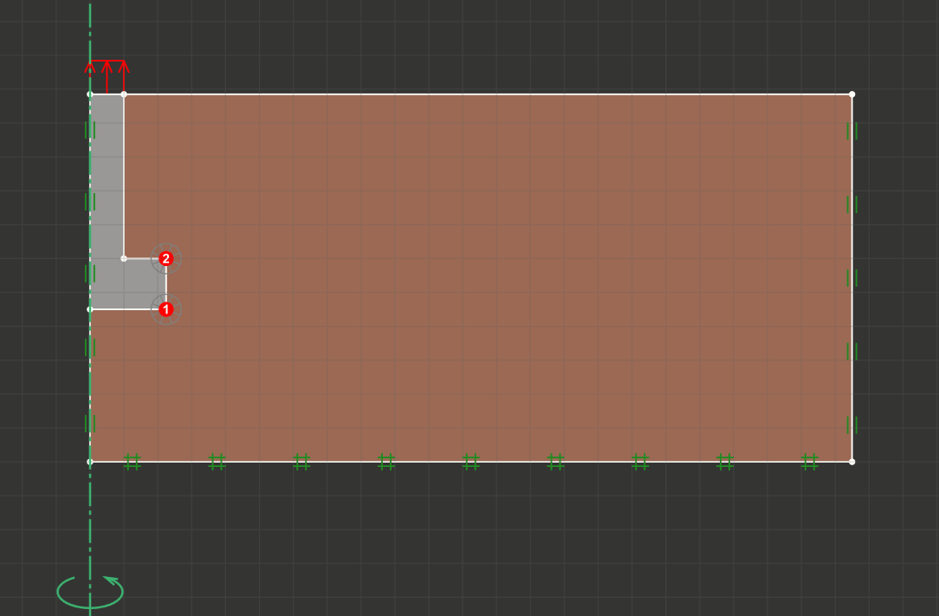

Figure 4.1: Typical numerical test set-up

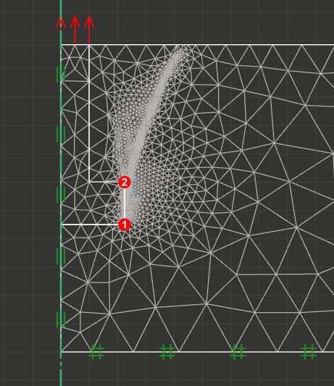

Figure 4.2: Typical mesh of the numerical simulation; number of mesh = 5000

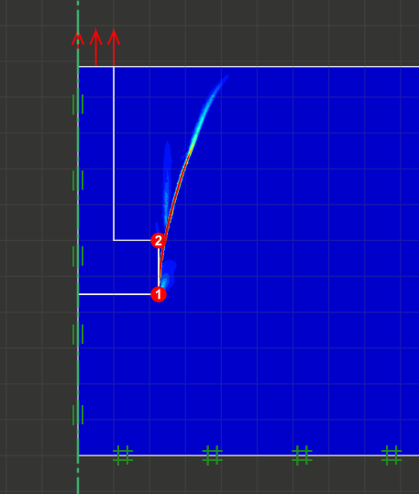

Figure 4.3: Typical result of the numerical simulation; 1st decile of the shear dissipation (kJ)

#### 4.0.0.1 Results of numerical analysis for finding the model that fits the centrifuge load—displacement curve

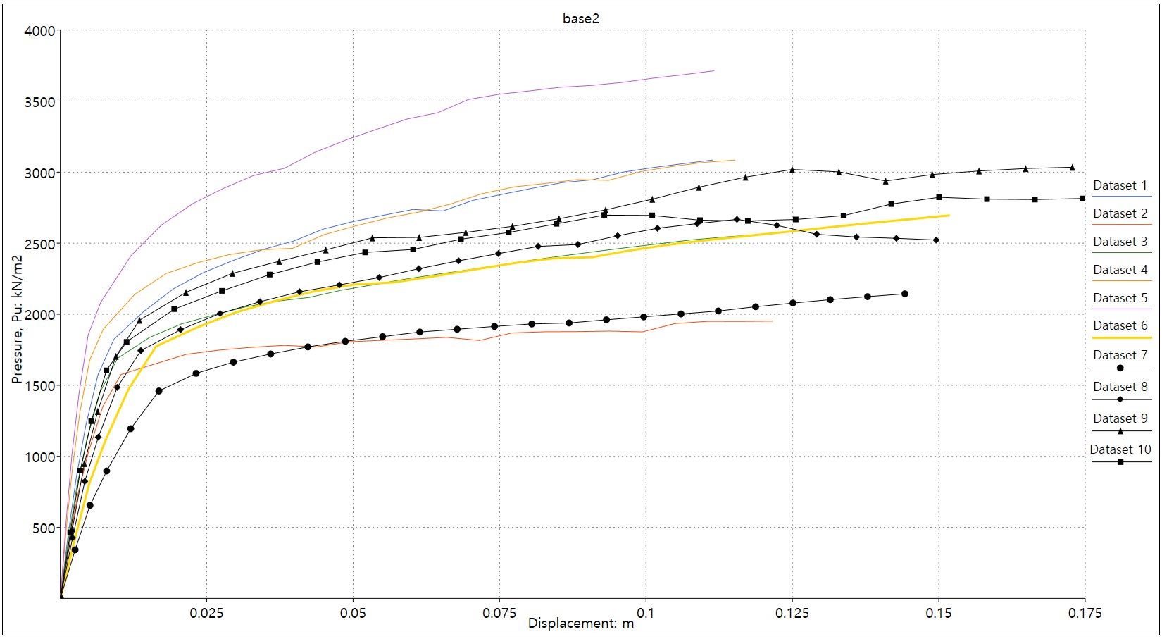

Figure 4.4: Code name base2; B=6.5m; B/D = 0.915

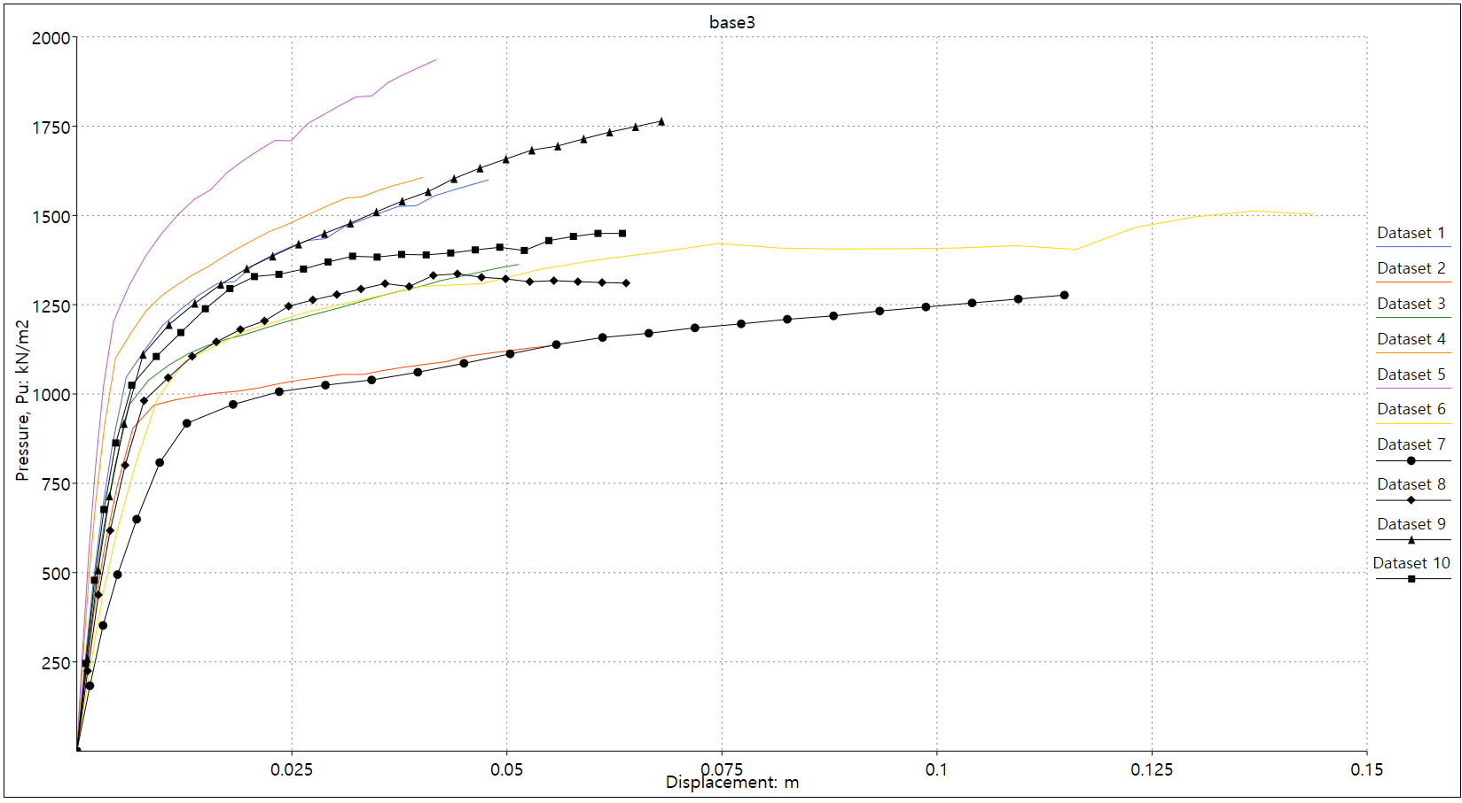

Figure 4.5: Code name base3; B=6.5m; B/D = 0.615

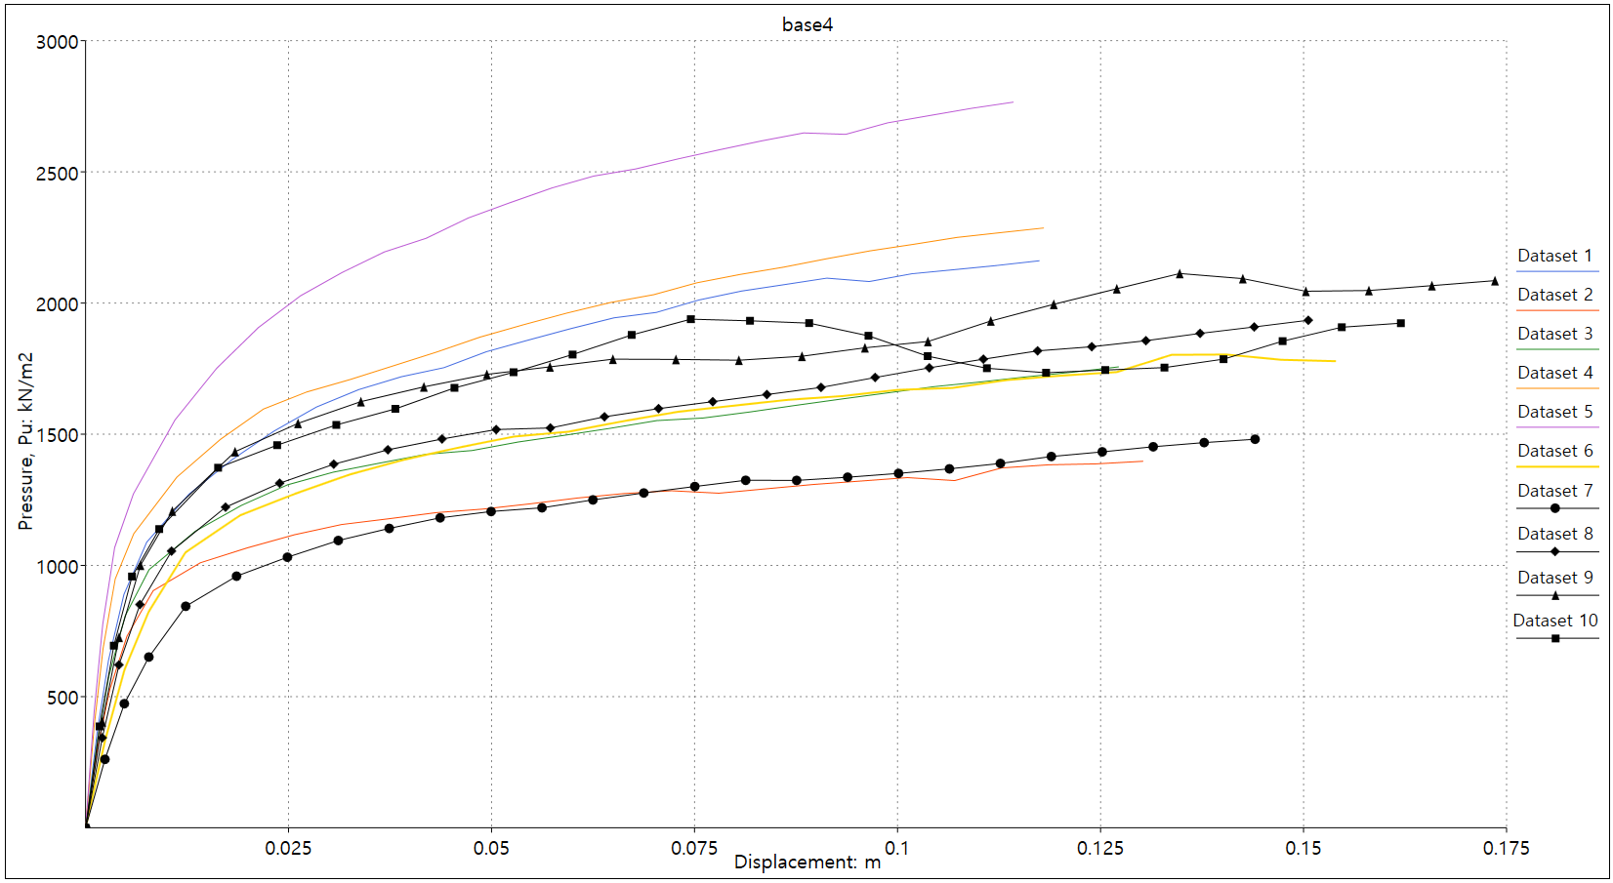

Figure 4.6: Code name base4; B=4.5m; B/D = 1.044

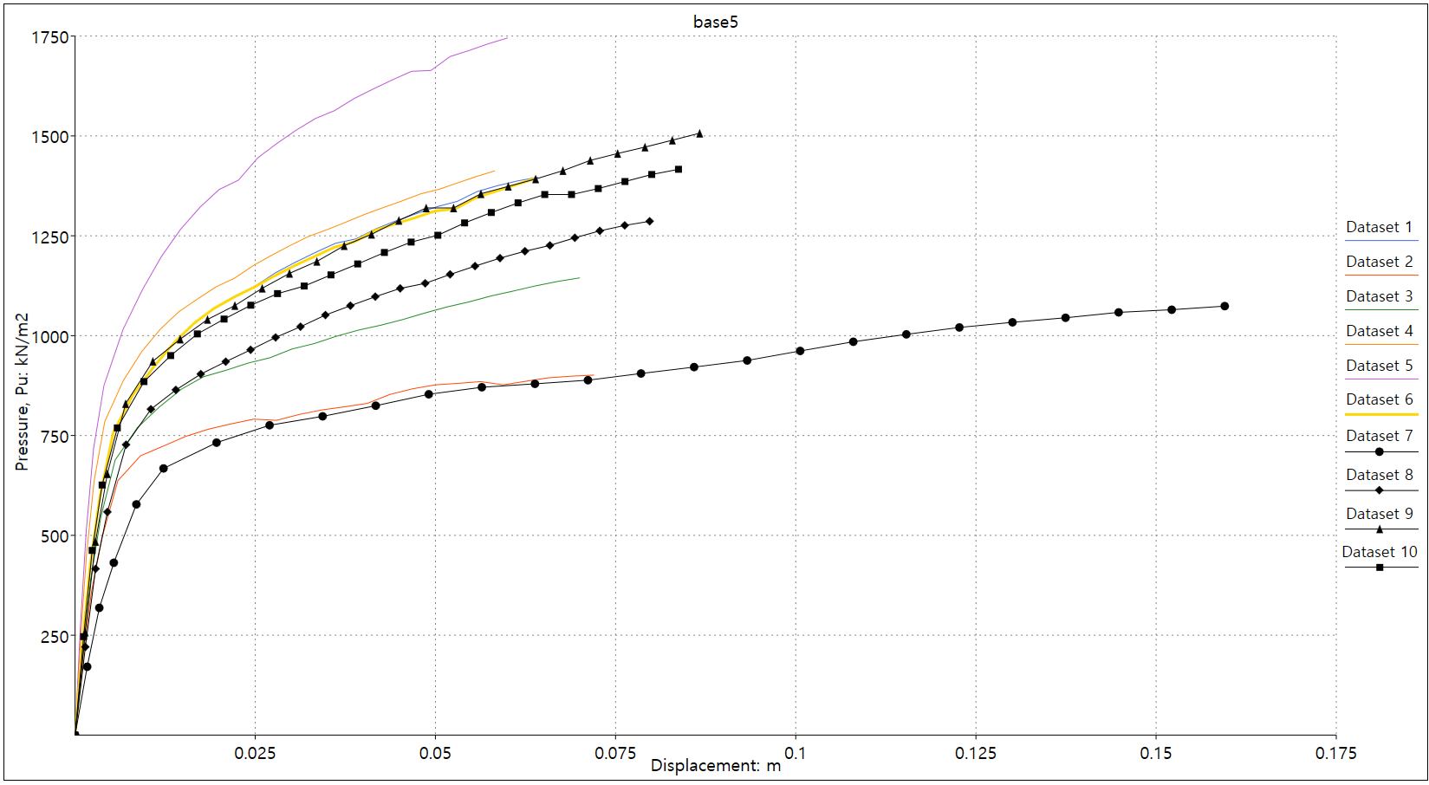

Figure 4.7: Code name base5; B=4.5m; B/D = 0.744

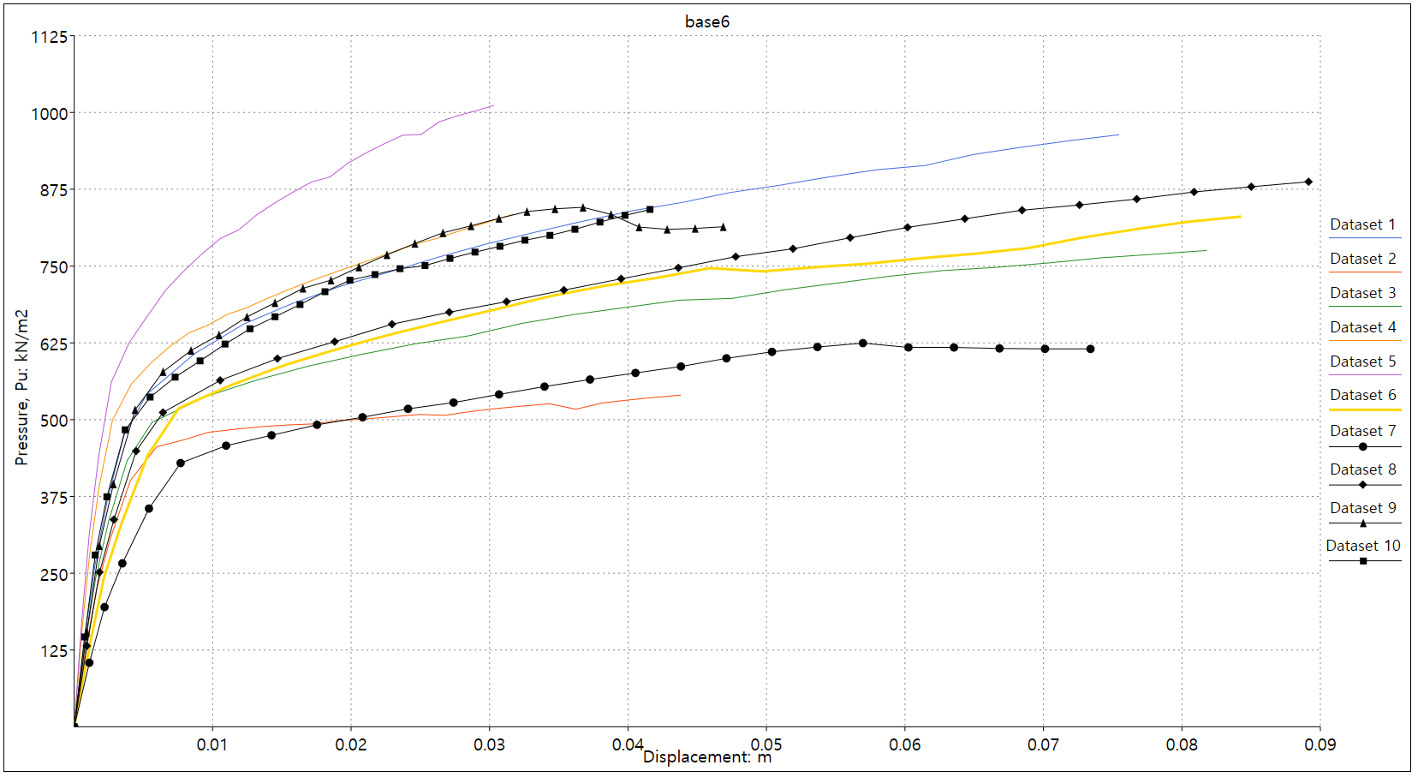

Figure 4.8: Code name base6; B=4.5m; B/D = 0.444

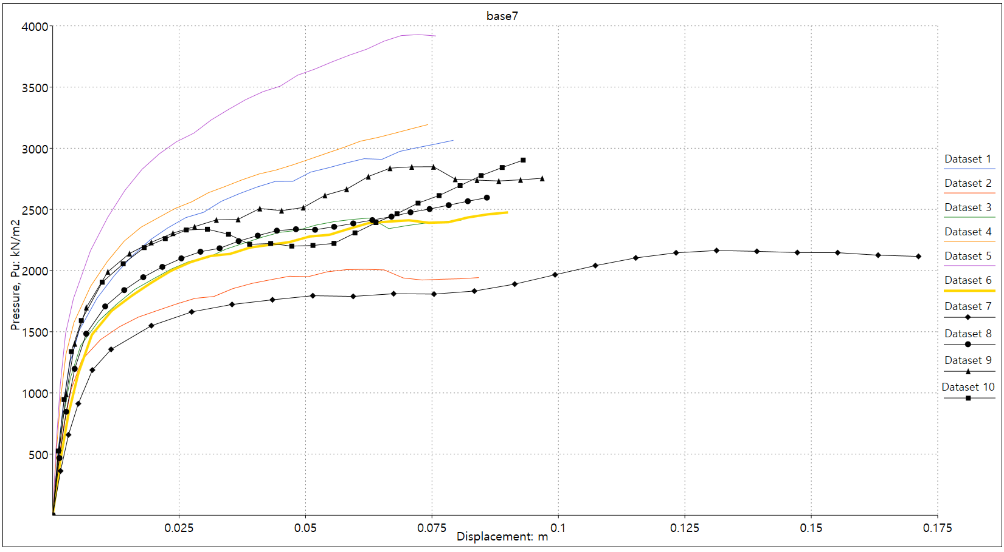

Figure 4.9: Code name base7; B=3.5m; B/D = 1.314

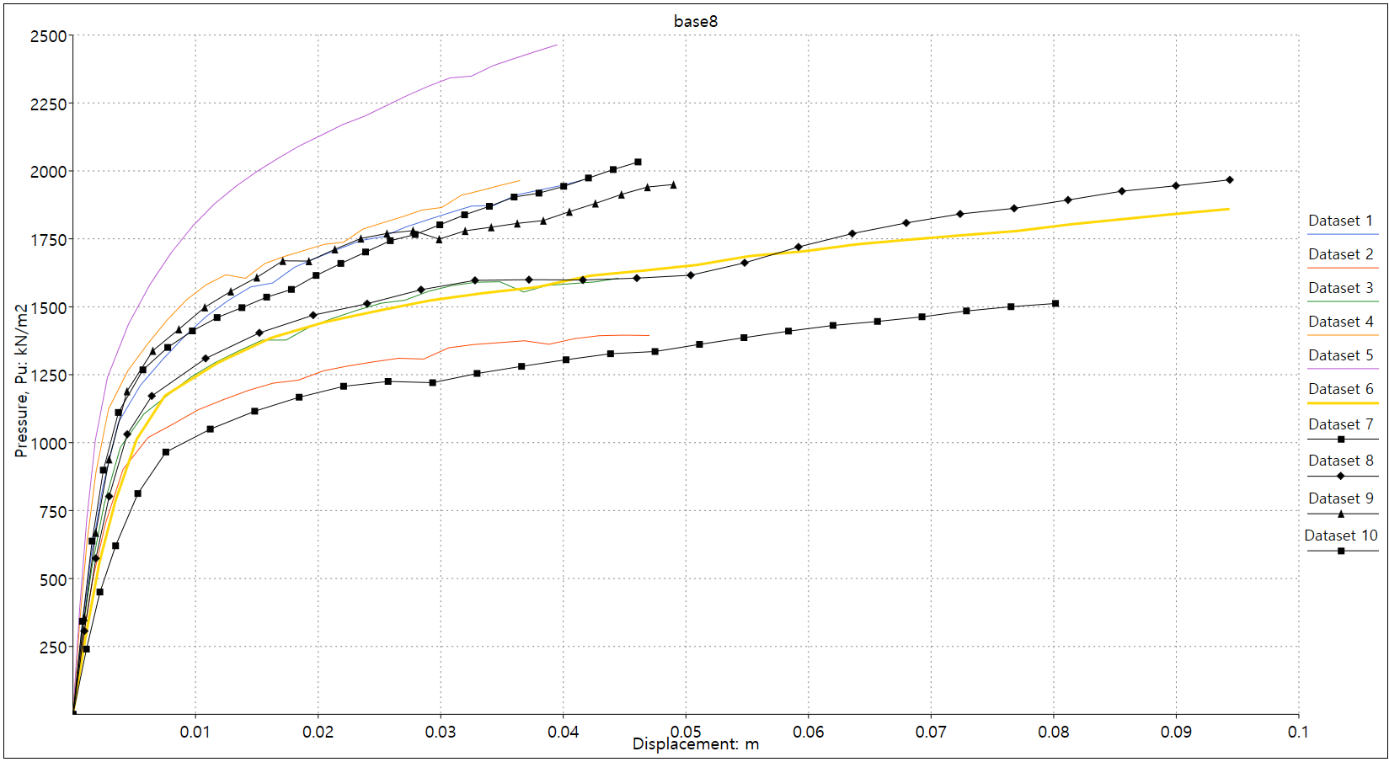

Figure 4.10: Code name base8; B=3.5m; B/D = 0.101

#### 4.0.0.2 Determination of model parameters

To evaluate the difference between the centrifuge test result and the model prediction, residual error was used:

$$Error=|\frac{y_{actual}−y_{estimated}}{y_{actual}}|×100\%$$

The goal is to find the model which best fits (or has the least error) the measured data. For the dense sand cases, Model C and H, whereas for the loose sand cases, Model B and G were chosen for the further studies.

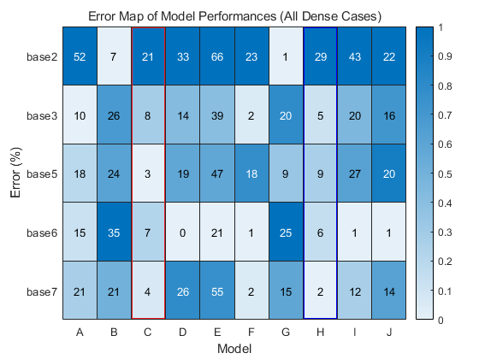

Figure 4.11: Heat-map of errors between cetrifuge test and model (dense cases); model C and H were selected among available 10 models

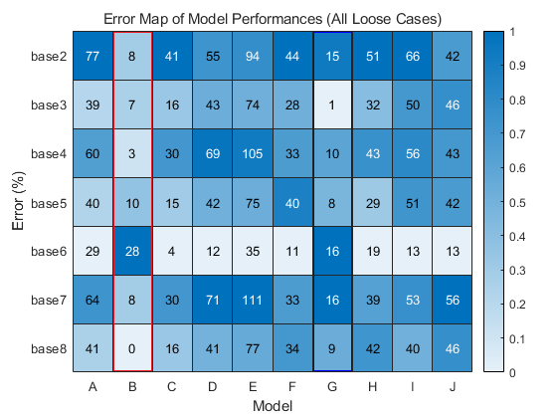

Figure 4.12: Heat-map of errors between cetrifuge test and model (loose cases); model B and G were selected among 10 available models

## 4.1 Comparison of the centrifuge test results with the chosen model

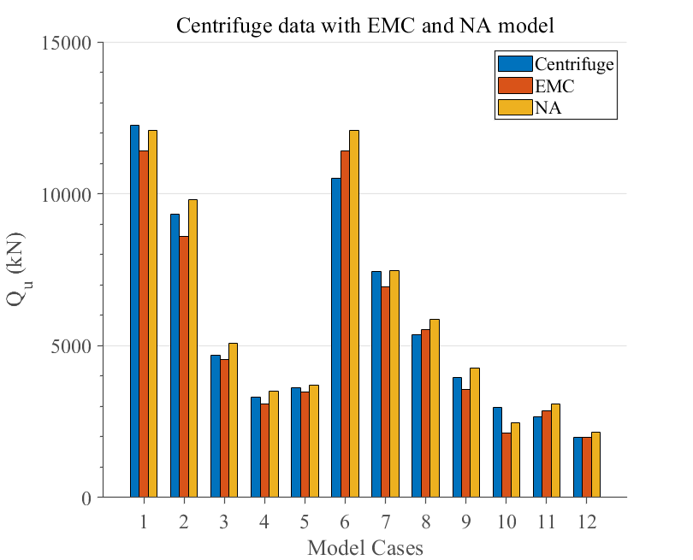

Figure 4.13: Bar-chart of centrifuge test and model (all cases); from left to right, 1: B=6.5m,D/B=1.3; 2: B=6.5m,D/B=1; 3: B=4.5m,D/B=1.3; 4: B=4.5m,D/B=1; 5: B=3.5m,D/B=1.6; 6: B=6.5m,D/B=1.3; 7: B=6.5m,D/B=1; 8: B=4.5m,D/B=1.6; 9: B=4.5m,D/B=1.3; 10: B=4.5m,D/B=1; 11: B=3.5m,D/B=1.6; 12: B=3.5m,D/B=1.3

#### 4.1.0.1 Result of load—displacement curves of the centrifuge measurement with EMC and NA models

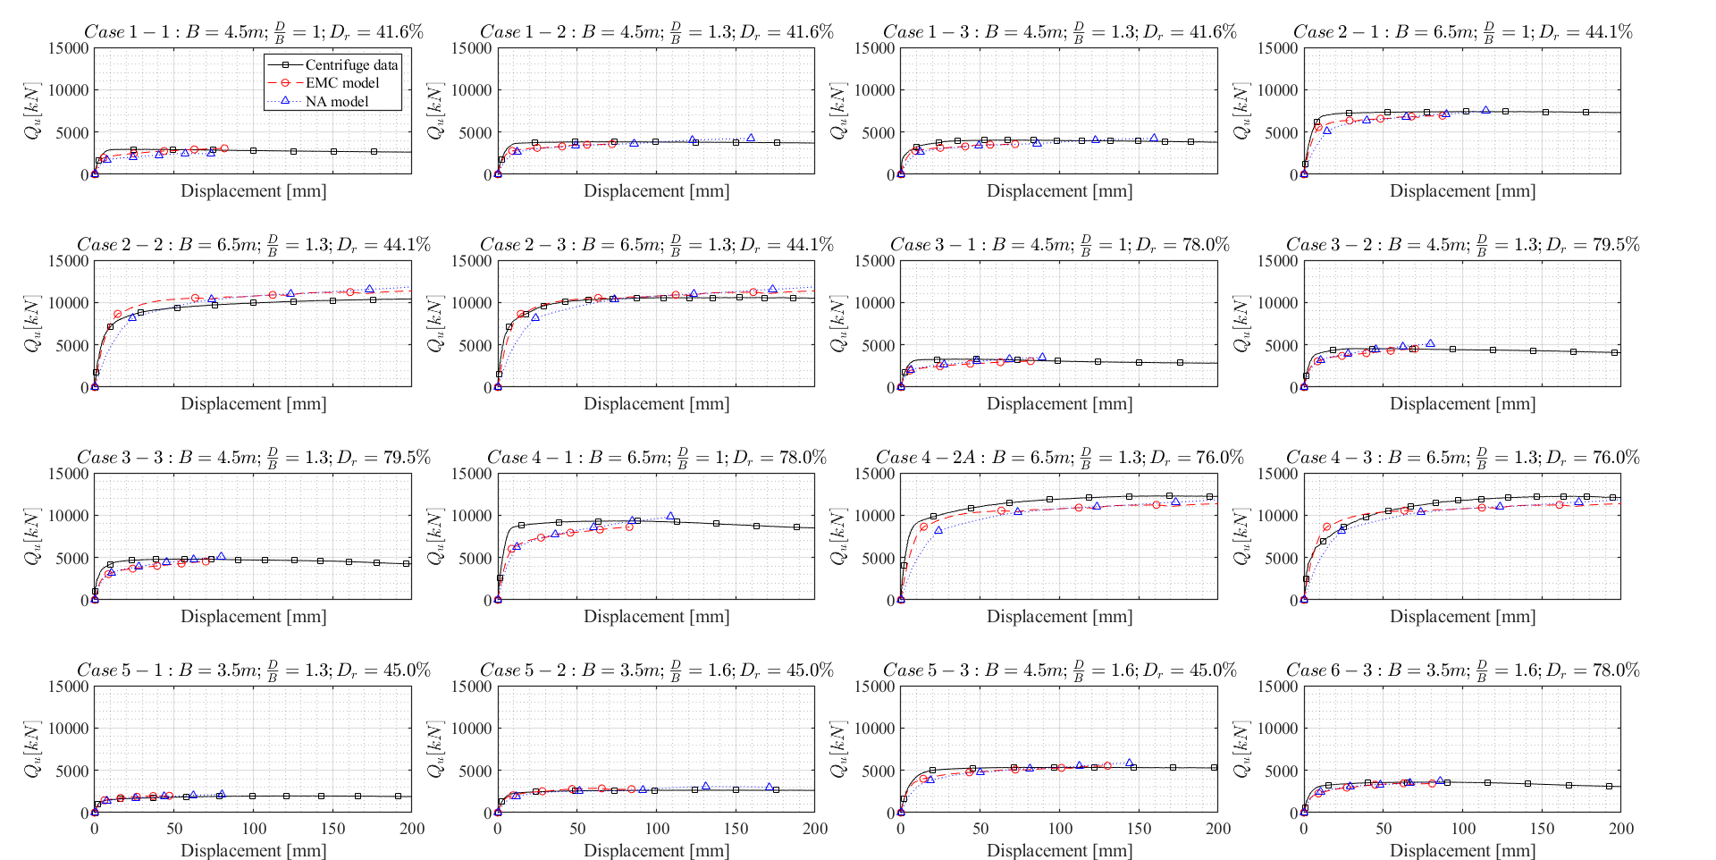

Figure 4.14: Comparison of centrifuge data with EMC and NA models

# (APPENDIX) Appendix

# 5 List of Load—Displacement Curves

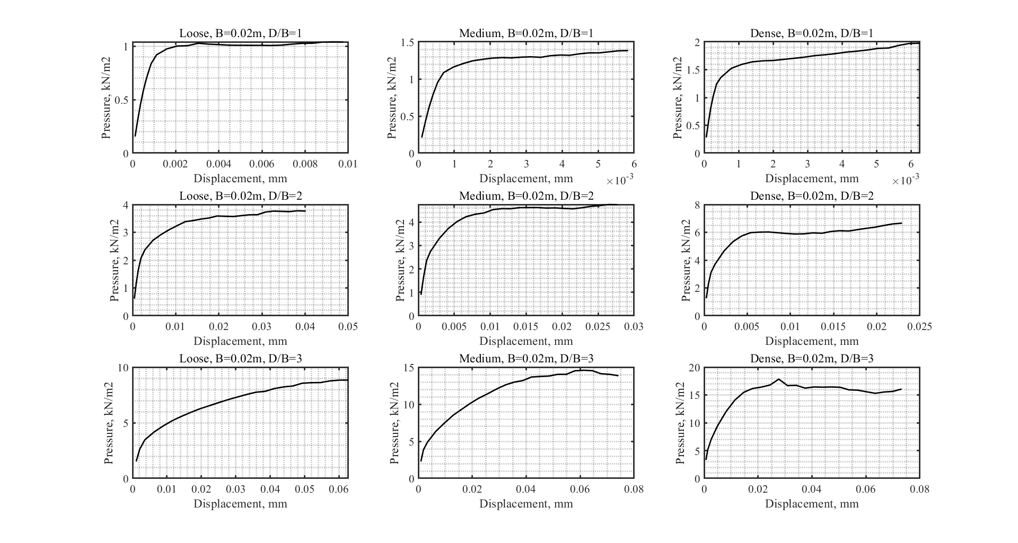

Figure 5.1: Cumulative load-displacement curves of uplift of plate anchor in loose, medium, dense sands; D/B = 1,2,3; B=0.02m

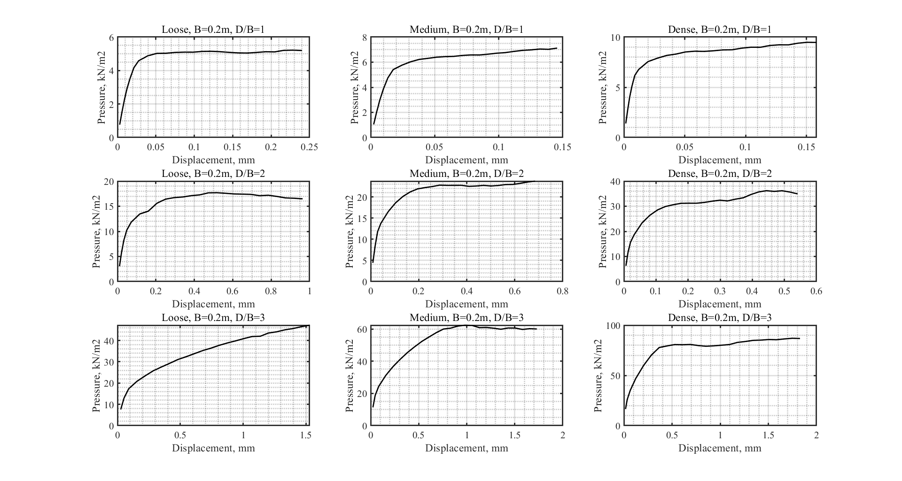

Figure 5.2: Cumulative load-displacement curves of uplift of plate anchor in loose, medium, dense sands; D/B = 1,2,3; B=0.2m

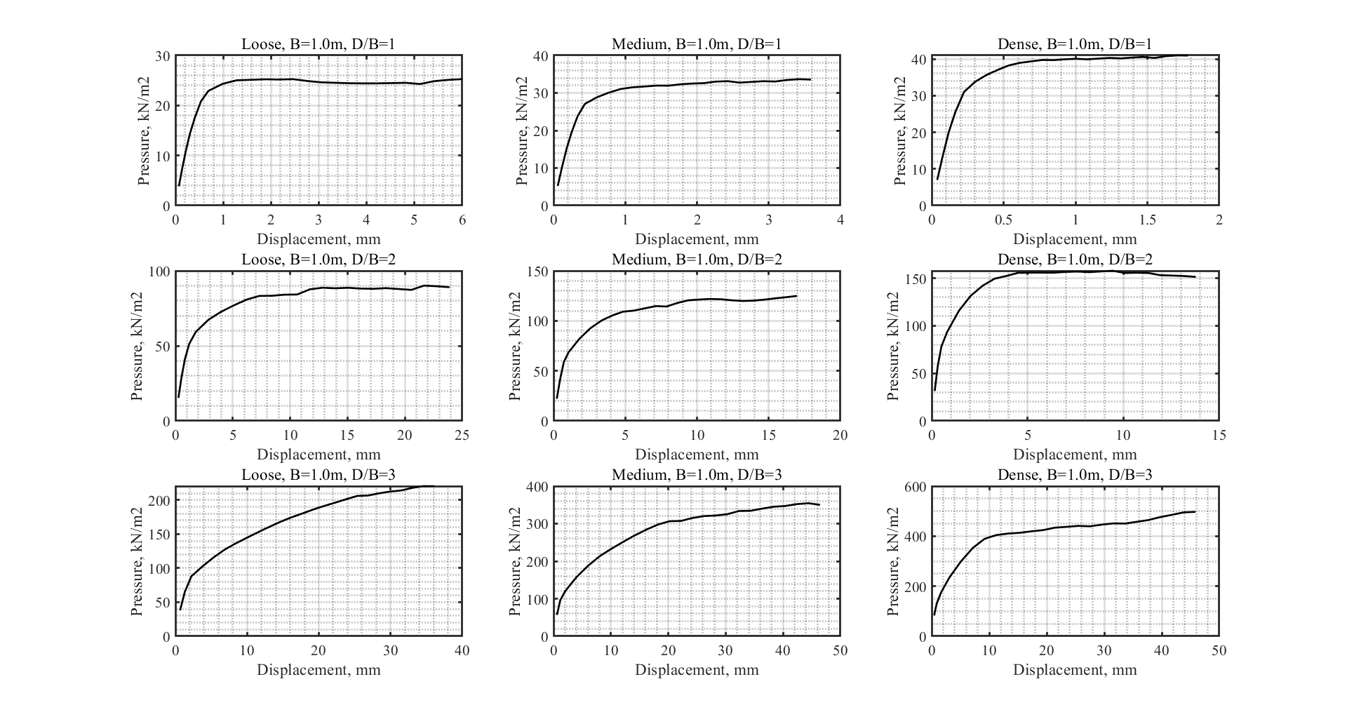

Figure 5.3: Cumulative load-displacement curves of uplift of plate anchor in loose, medium, dense sands; D/B = 1,2,3; B=1.0m

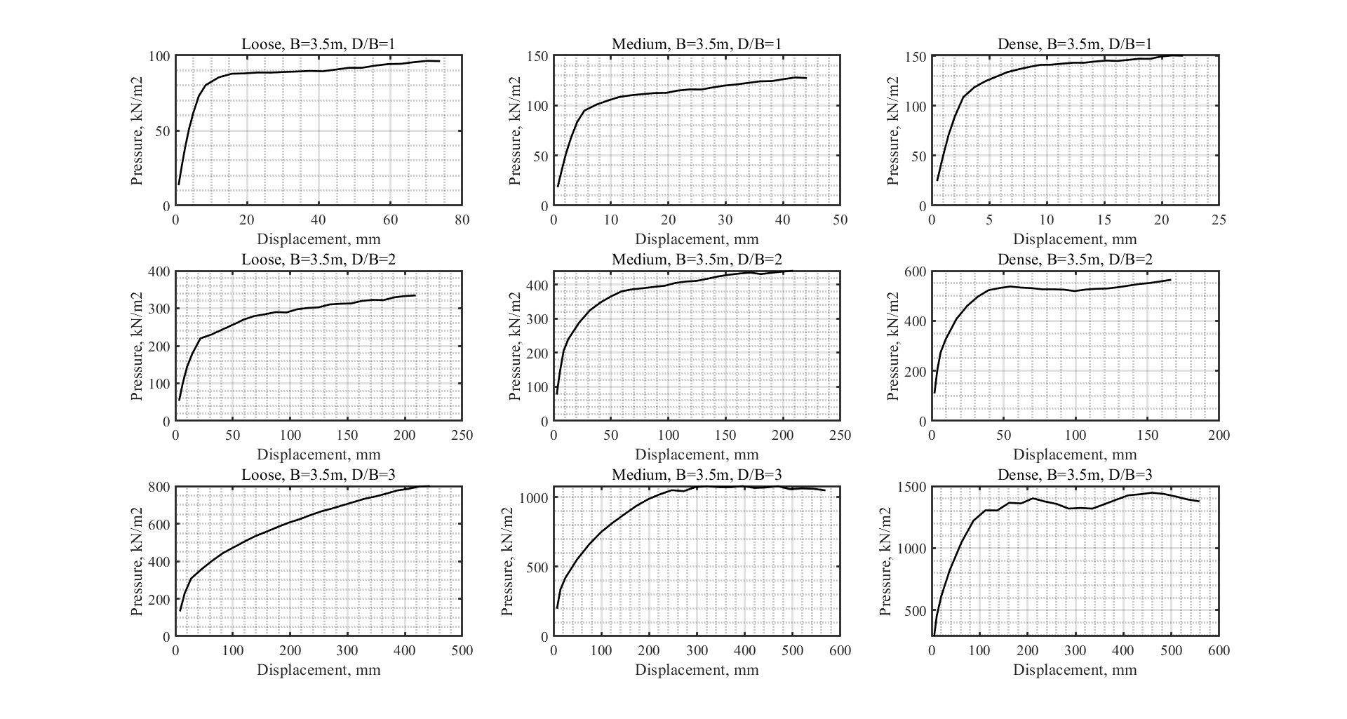

Figure 5.4: Cumulative load-displacement curves of uplift of plate anchor in loose, medium, dense sands; D/B = 1,2,3; B=3.5m

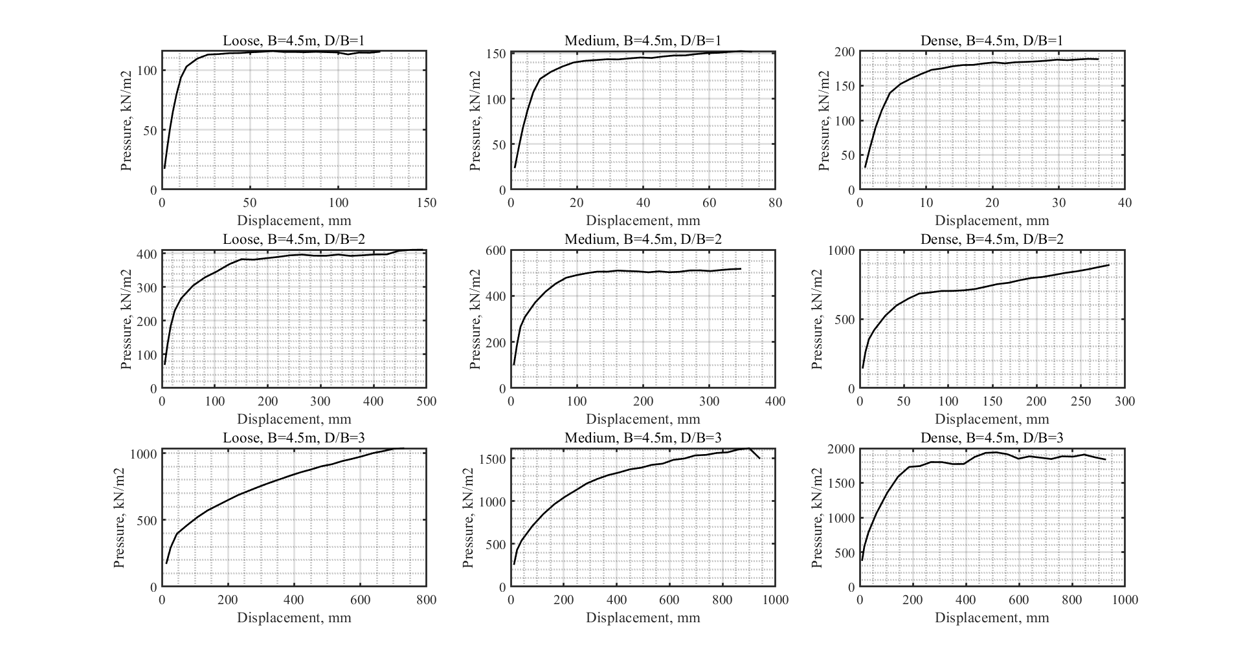

Figure 5.5: Cumulative load-displacement curves of uplift of plate anchor in loose, medium, dense sands; D/B = 1,2,3; B=4.5m

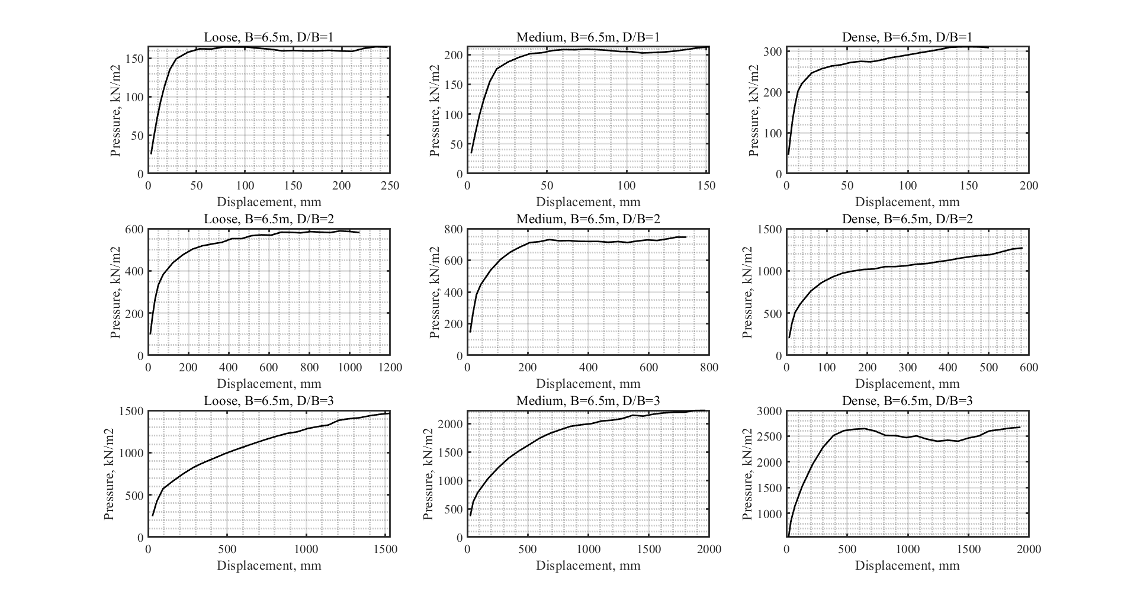

Figure 5.6: Cumulative load-displacement curves of uplift of plate anchor in loose, medium, dense sands; D/B = 1,2,3; B=6.5m

# (REFERENCES) References

# 6 REFERENCES

Wood, D. M. (2017). Geotechnical modelling. CRC press.

Doherty, J. P., & Muir Wood, D. (2013). An extended Mohr–Coulomb (EMC) model for predicting the settlement of shallow foundations on sand. Géotechnique, 63(8), 661-673.

Gajo, A., & Wood, M. (1999). Severn–Trent sand: a kinematic-hardening constitutive model: the q–p formulation. Géotechnique, 49(5), 595-614.

Krabbenhoft, S., Krabbenhoft, K., & Christensen, R. Limit analysis of the bearing capacity of strip-and circular footings on a layer of sand overlying clay.

Sakai, T., & Tanaka, T. (2007). Experimental and numerical study of uplift behavior of shallow circular anchor in two-layered sand. Journal of geotechnical and geoenvironmental engineering, 133(4), 469-477.

Tanaka, T., & Sakai, T. (1993). Progressive failure and scale effect of trap-door problems with granular materials. Soils and Foundations, 33(1), 11-22.

Sakai, T., & Tanaka, T. (1998). Scale effect of a shallow circular anchor in dense sand. Soils and Foundations, 38(2), 93-99.

Sakai, T., & Tanaka, T. (2007). Experimental and numerical study of uplift behavior of shallow circular anchor in two-layered sand. Journal of geotechnical and geoenvironmental engineering, 133(4), 469-477.

Riyad, A. S. M., Rokonuzzaman, M., & Sakai, T. (2020). Progressive failure and scale effect of anchor foundations in sand. Ocean Engineering, 195, 106496.

Kumar, J., & Kouzer, K. M. (2008). Vertical uplift capacity of horizontal anchors using upper bound limit analysis and finite elements. Canadian Geotechnical Journal, 45(5), 698-704.

Riyad, A. S. M., Rokonuzzaman, M., & Sakai, T. (2020). Effect of using different approximation models to the exact Mohr–Coulomb material model in the FE simulation of Anchor Foundations in sand. International Journal of Geo-Engineering, 11(1), 1-21.

Riyad, A. S. M., Rokonuzzaman, M., & Sakai, T. (2020). Progressive failure and scale effect of anchor foundations in sand. Ocean Engineering, 195, 106496.

Roy, A., Chow, S. H., O’Loughlin, C. D., & Randolph, M. F. (2021). Towards a simple and reliable method for calculating uplift capacity of plate anchors in sand. Canadian Geotechnical Journal, 58(9), 1314-1333.